**Hands-On Xray:**

Open Jira account:

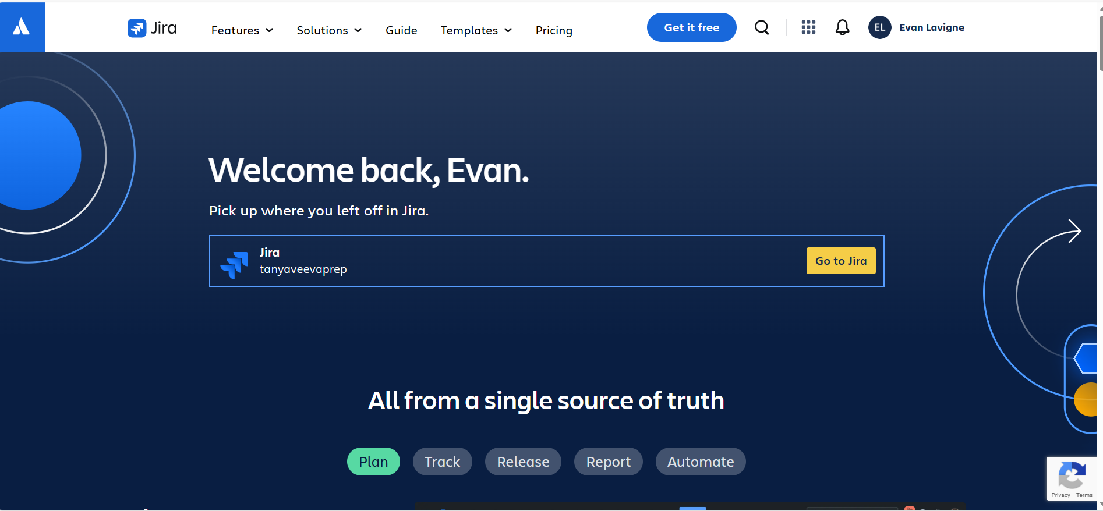

Go to Apps and Enable Xray :

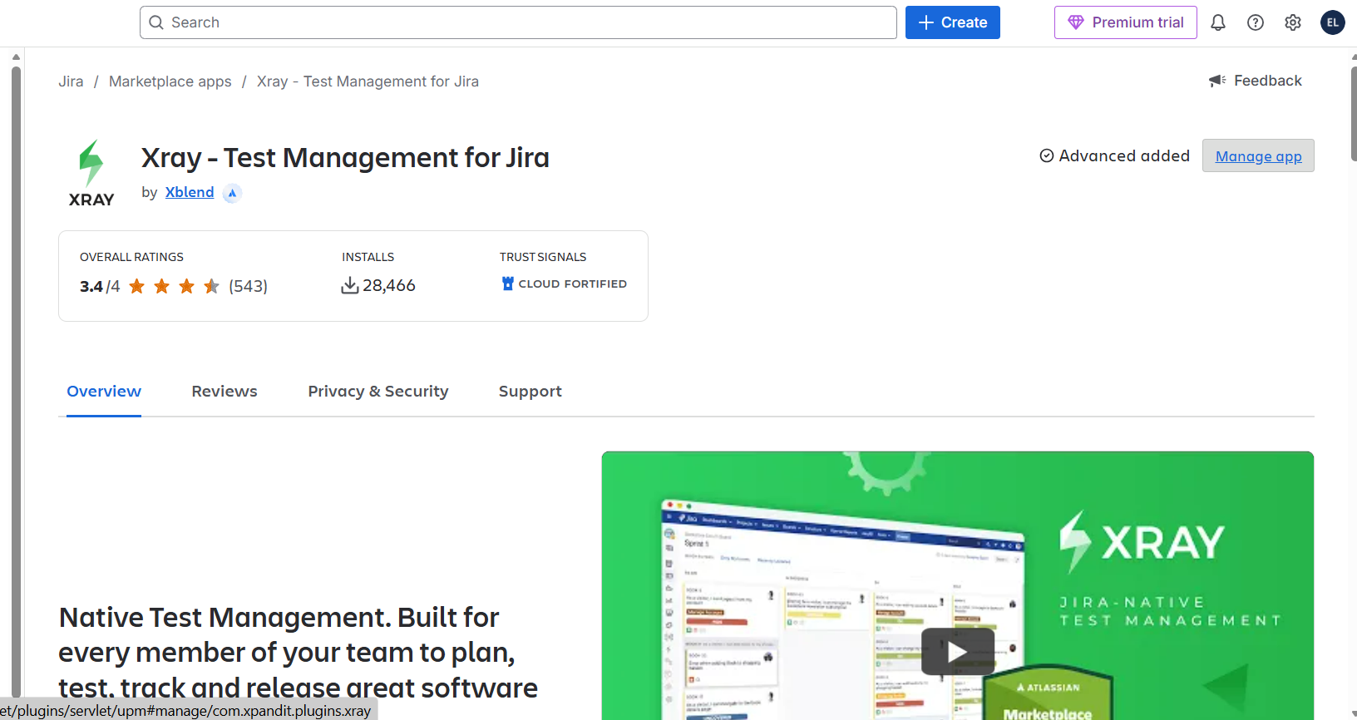

**Xray Work types adding in Team managed space[Manual Configuration is needed):**

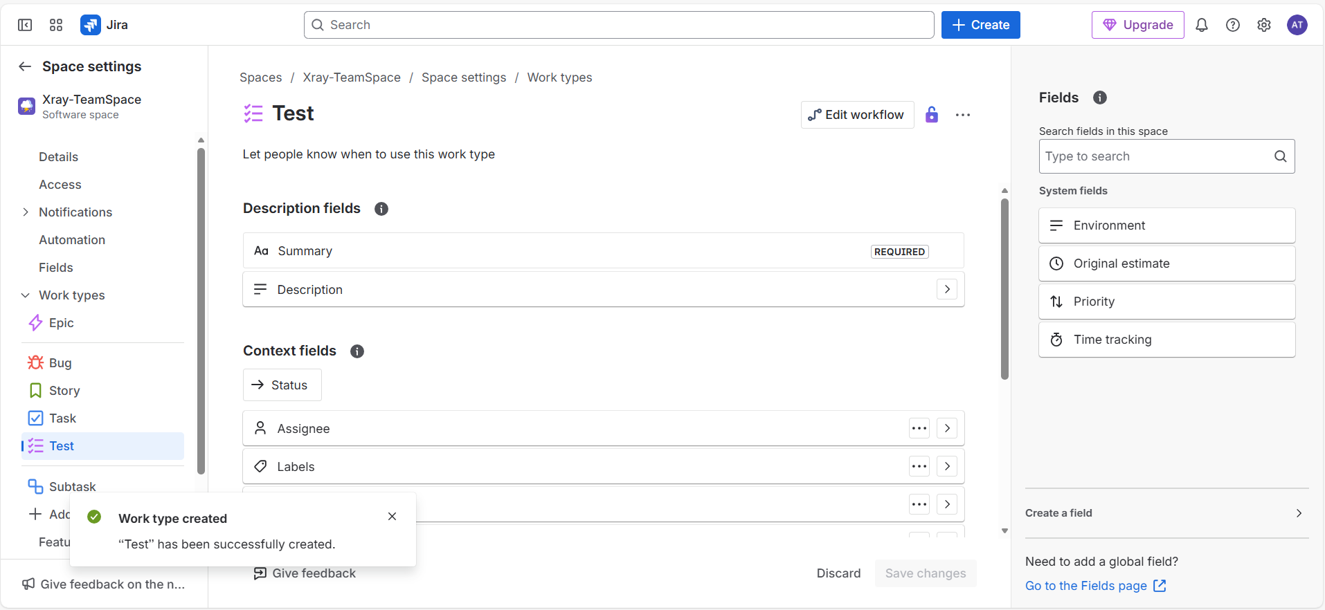

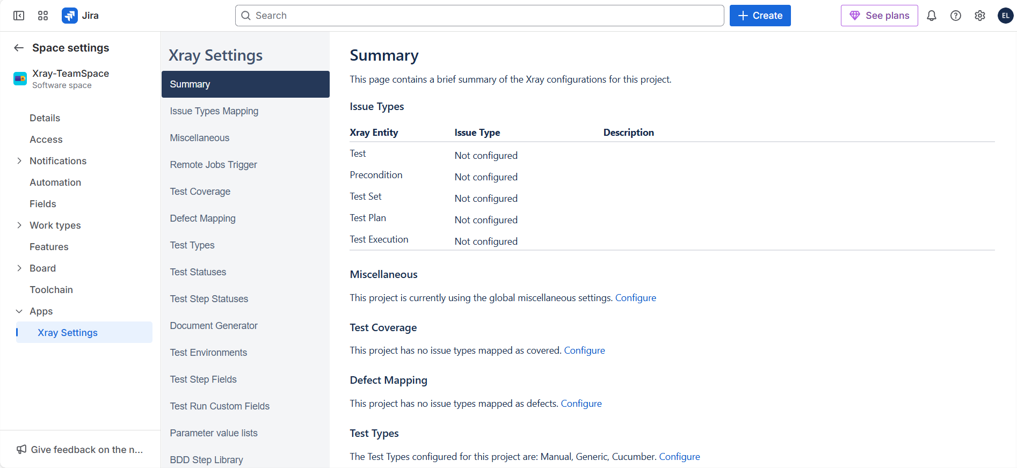

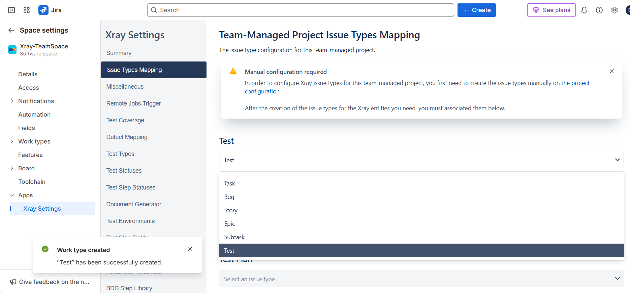

Keep on Creating worktypes and then map them in issue Types Mapping of Xray Settings

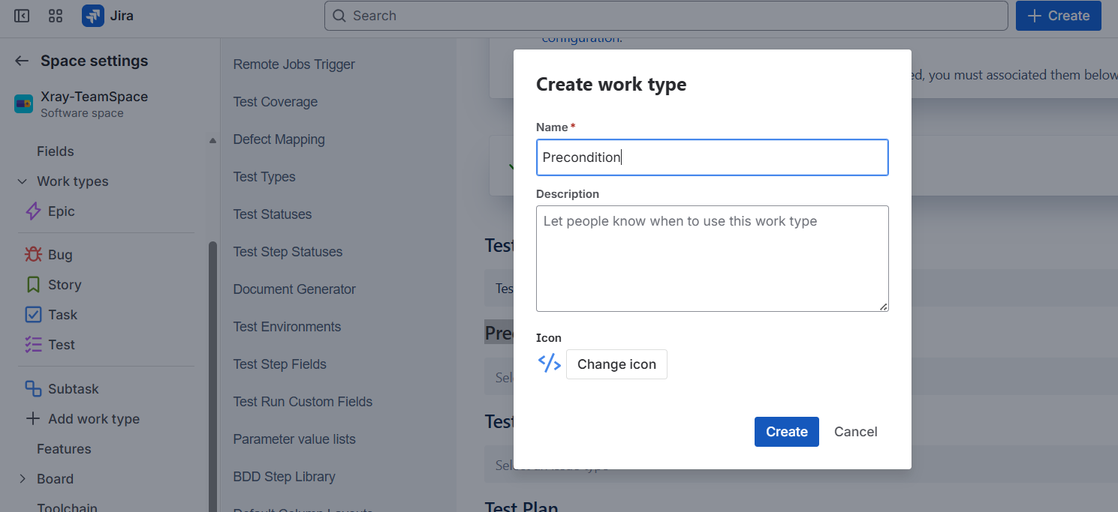

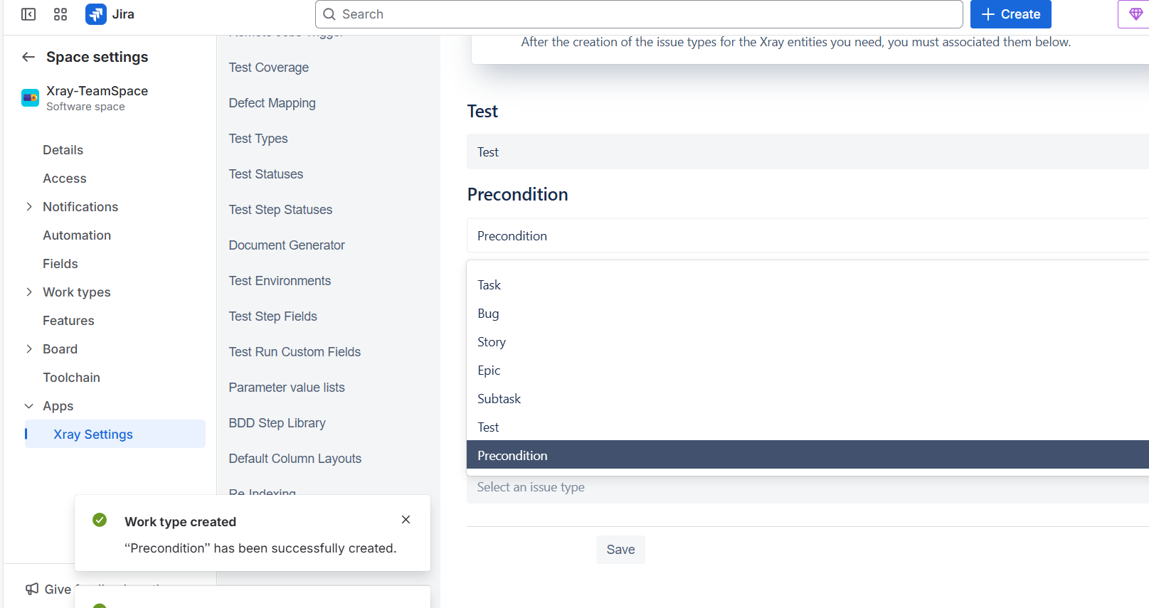

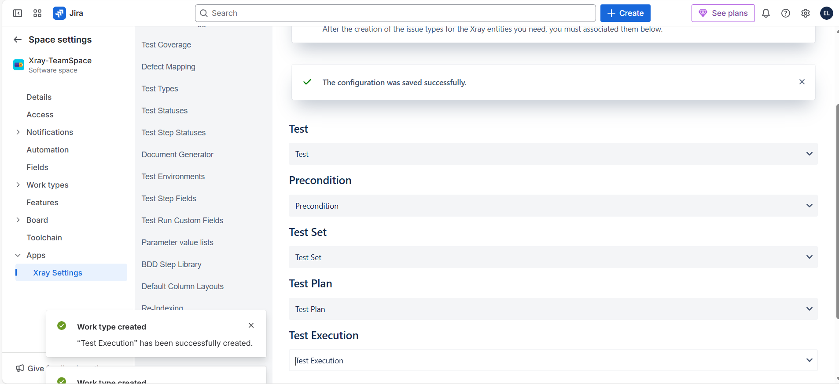

After adding the worktypes/issue types, you get to see them in your options regarding the specific project/space as shown below:

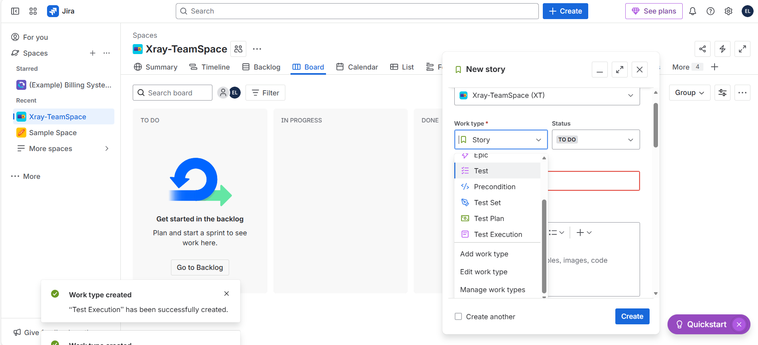

As for Company Space, no need to add the issue types manually since they are already added but not present in the project.

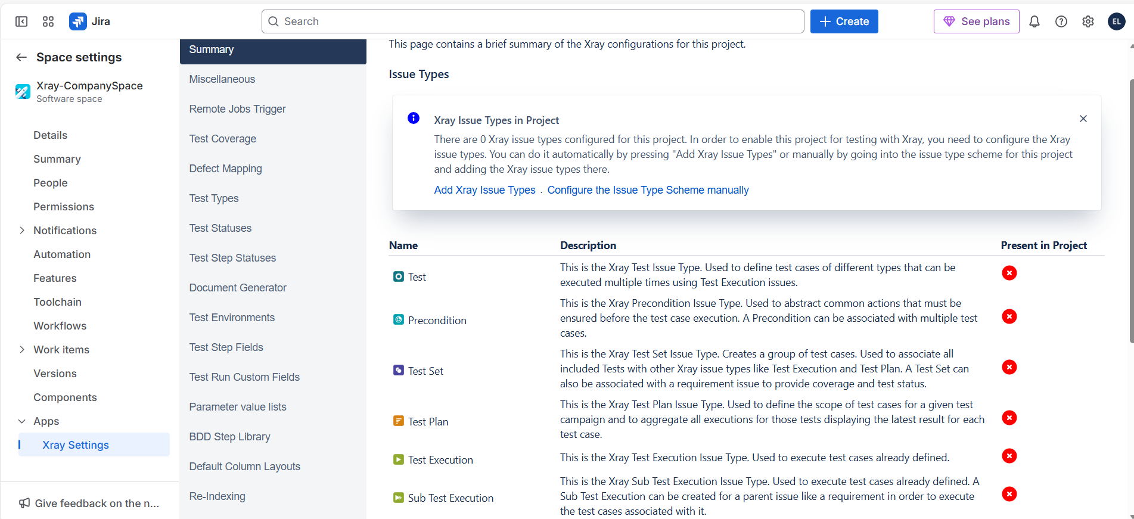

Simply click on Add Xray Issue Types to enable the issue types in the project

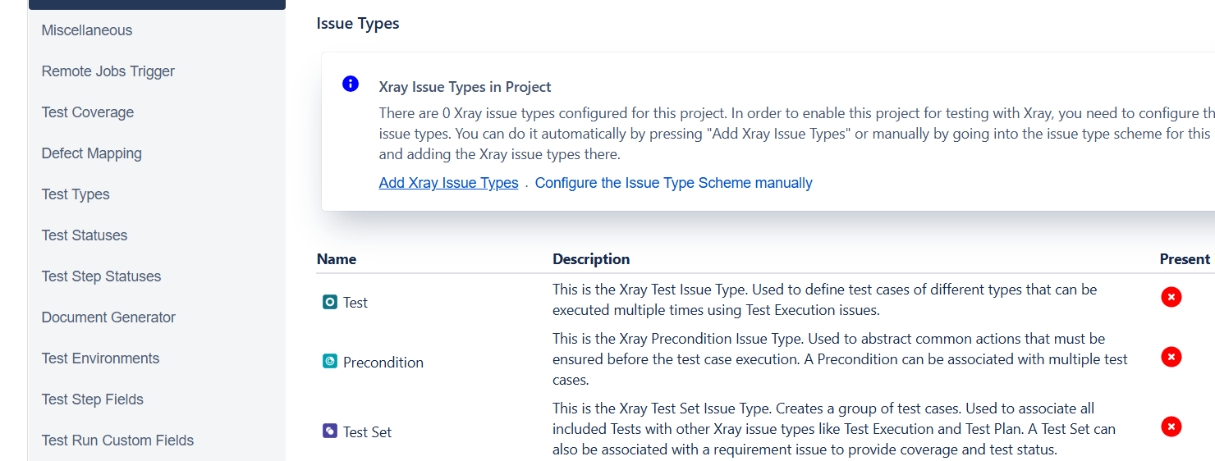

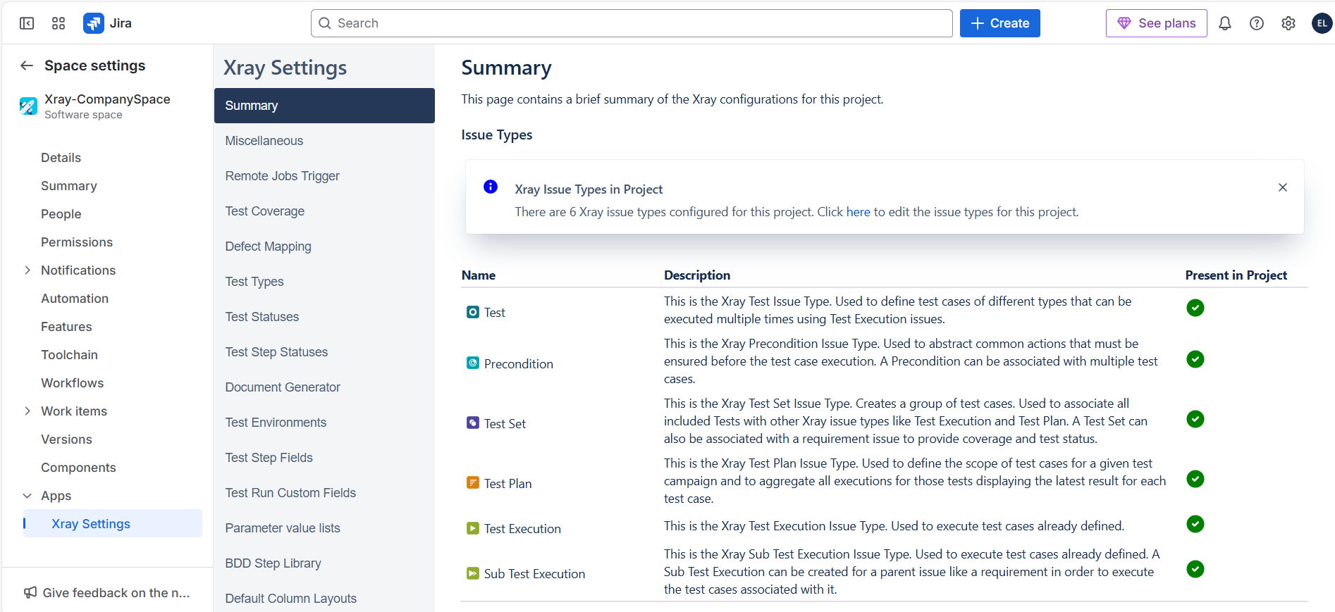

So, Once I go and check now the work types related to the project, all the Xray Issue types will be visible in the project:

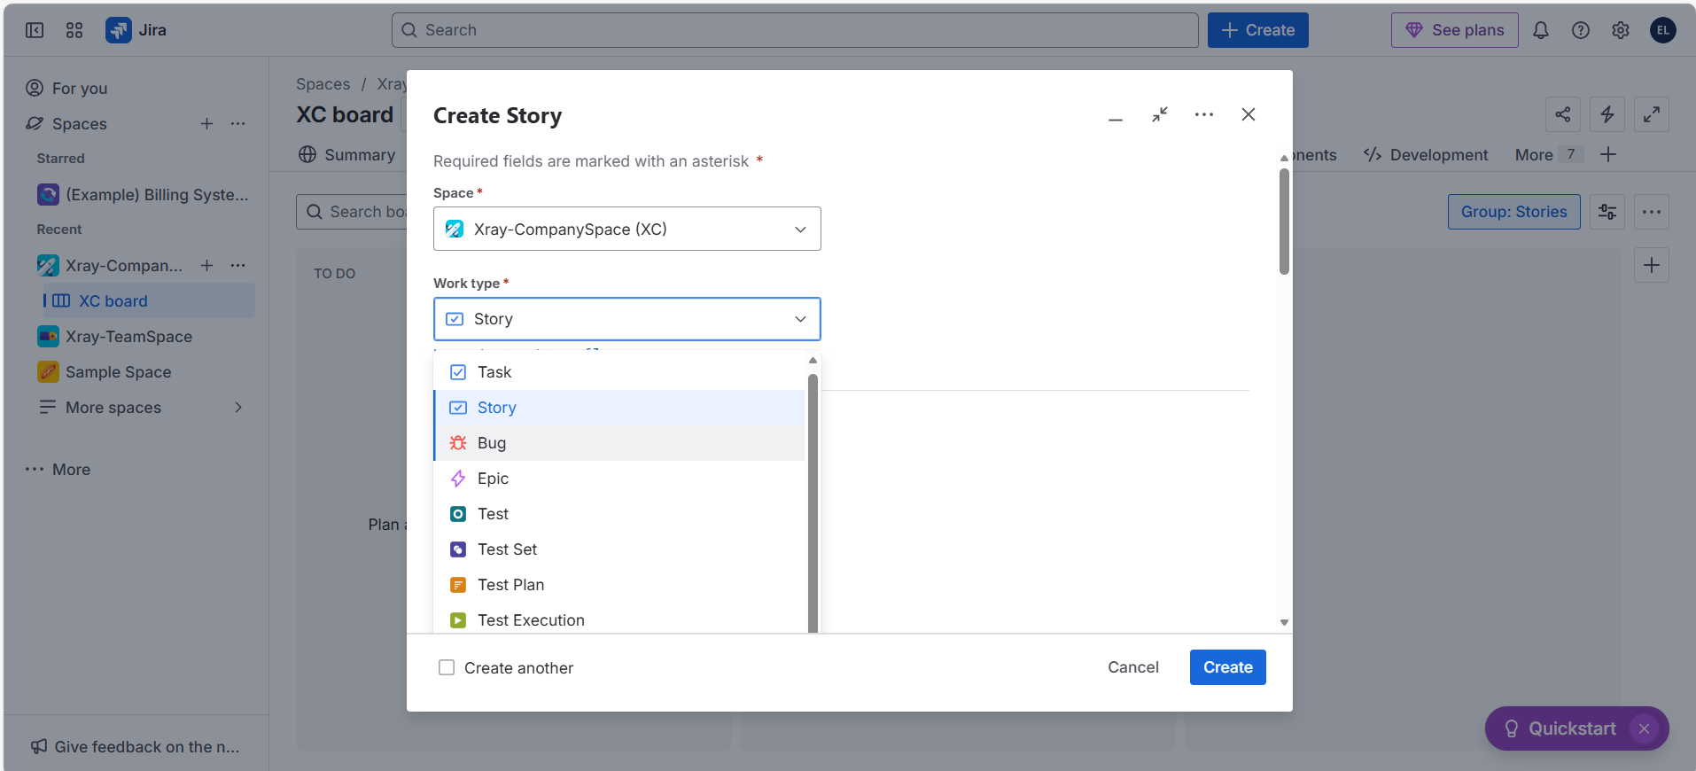

Xray Testing Board:

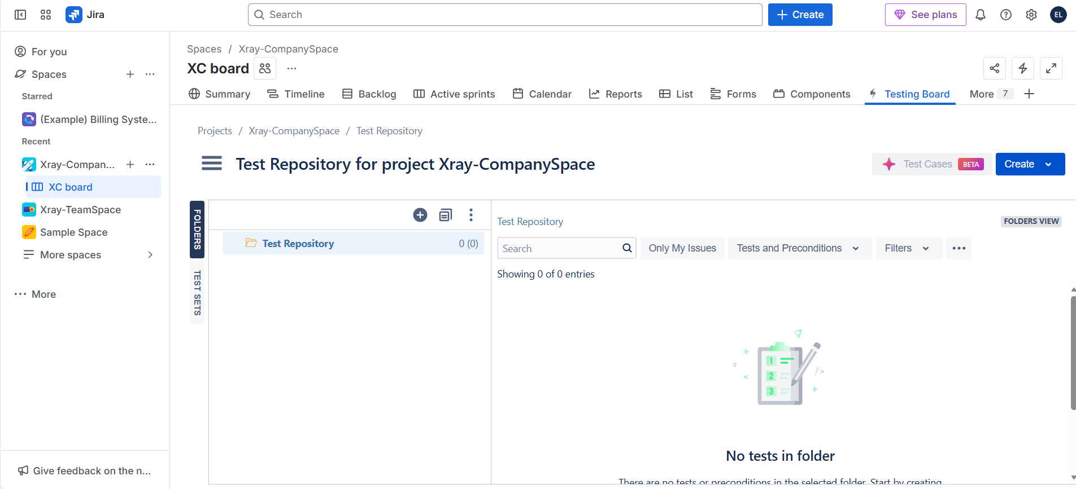

**Software Testing Lifecycle in Xray:**

Requirement Analysis

Test Planning

Test Case Development

Test Execution

Post test execution 🡪 reporting

**Xray Documentation :** [**LINK**](https://docs.getxray.app/space/XRAYCLOUD/44566476/About+Xray)

[Xray](https://www.getxray.app/) is a complete Test Management tool for [Jira](https://www.atlassian.com/software/jira). It is a full-featured app that does not require any other software to run.

Xray supports the entire Testing life cycle:[Test planning](https://docs.getxray.app/space/XRAYCLOUD/44565044), Test design, [Test execution](https://docs.getxray.app/space/XRAYCLOUD/44565117), and [Test reporting](https://docs.getxray.app/space/XRAYCLOUD/44566291). We do this by using special Jira Work item types, so you can utilize all the Jira benefits that you are used to.

The sprint (mostly 2-4 weeks cycle) will be started by the Agile Project manager or Scrum Master (mostly).

After sprint planning, all the team members discuss about backlog (work still need to do 🡪 Epic [Big piece of work], User Stories [Granular form of work that can be completed within the sprint]); As a Tester, we are not going to involve in any of the sprint starting and all. We are going to focus only on what needs to be tested, how it needs to be tested and what test cases are need to be written.

When the sprint is started, every team member comes into the picture.

**TEST PLAN :**

**Test planning:** It will be done in Sprint Planning.

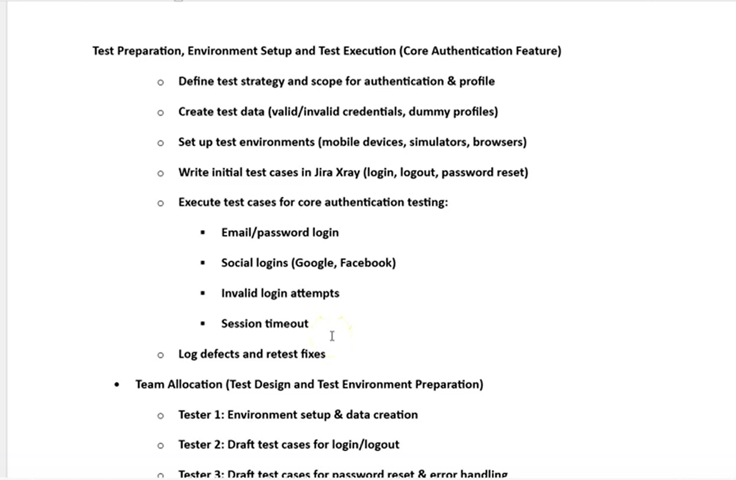

**Adding Test Plan in Xray Jira:**

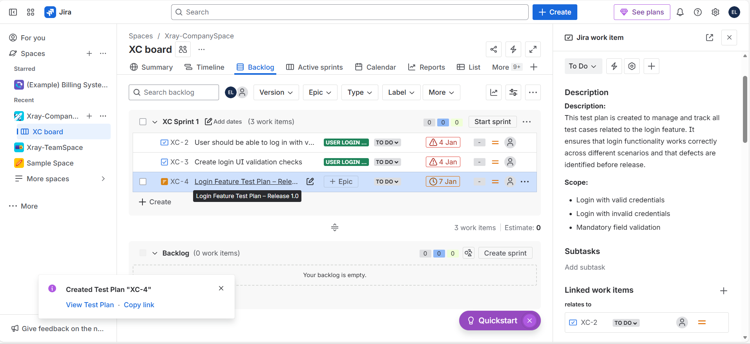

In Test plan, you can mention the tester name with @username so that the corresponding work will be notified to respective username mentioned.

Test manager or Test Lead will take care of creating the Test Plan.

Release test plan (Master test plan) is the parent test plan of all the Epics test plans.

Also whether the test plan to be part of sprint (i.e., on board) or not, it is optional choice.

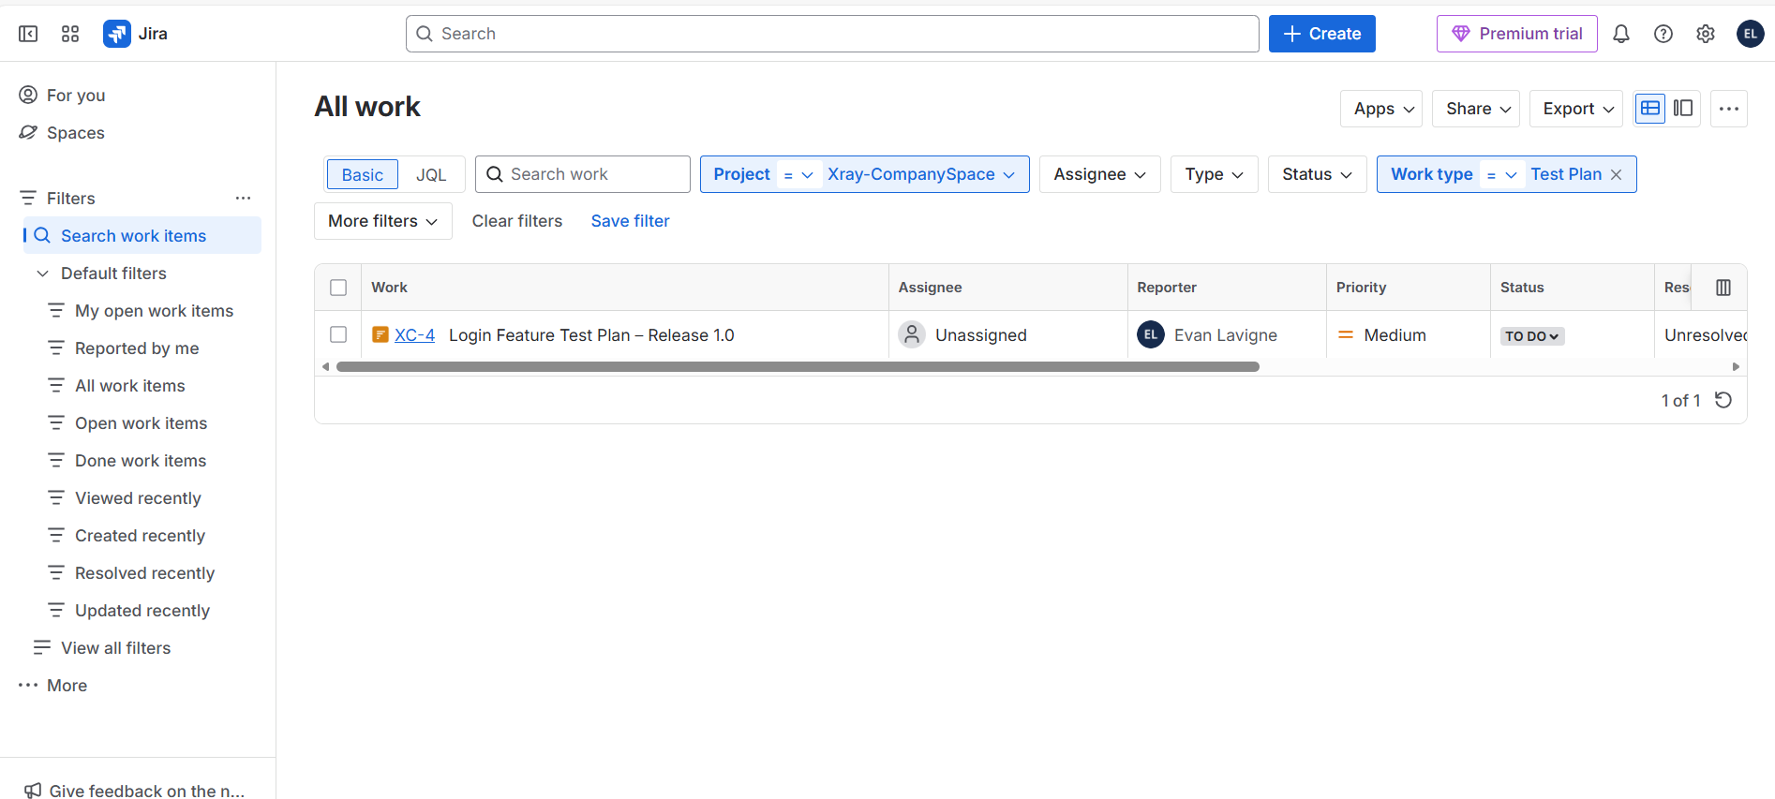

**TEST : (Test case)**

**Creating Test Cases in Xray Jira:**

**NOTE:**

**1️⃣ Parent vs Relates To – BIG DIFFERENCE**

**🔹 Parent**

* **Not your choice**
* **Mandatory rules apply**
* Controlled by **issue hierarchy**

**🔹 Relates To**

* **Your choice**
* No hierarchy rules
* Used only for **logical/reference linking**

**2️⃣ PARENT – WHAT IS ALLOWED (MANDATORY RULES)**

Parent is based on **issue type**, not your wish.

**Standard Jira hierarchy:**

Epic

└── Story / Task / Bug

└── Sub-task

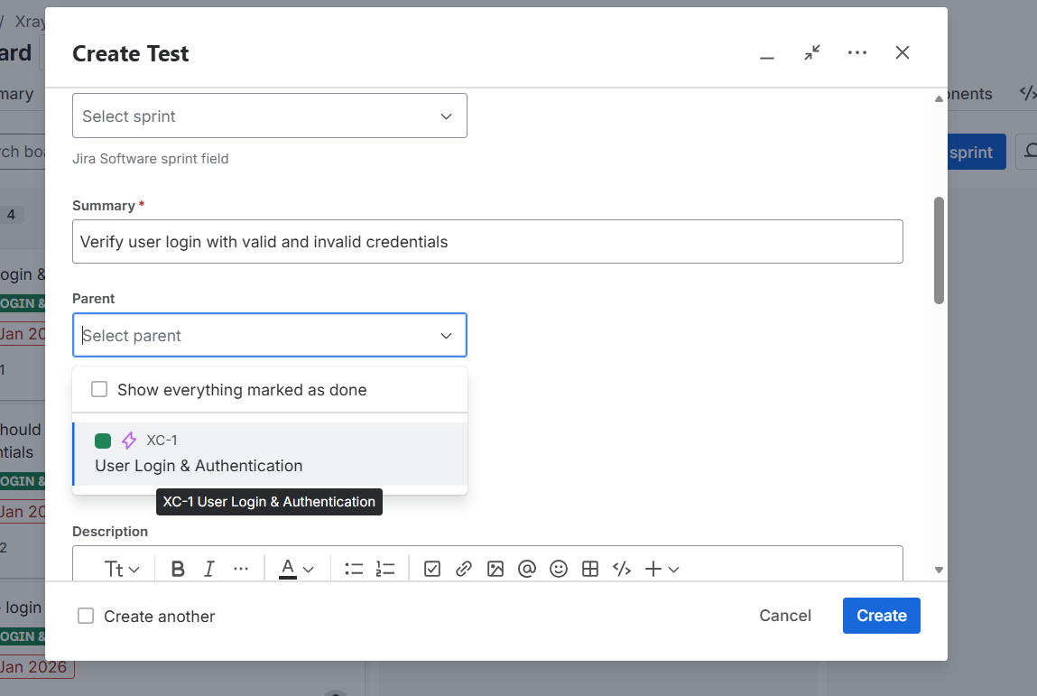

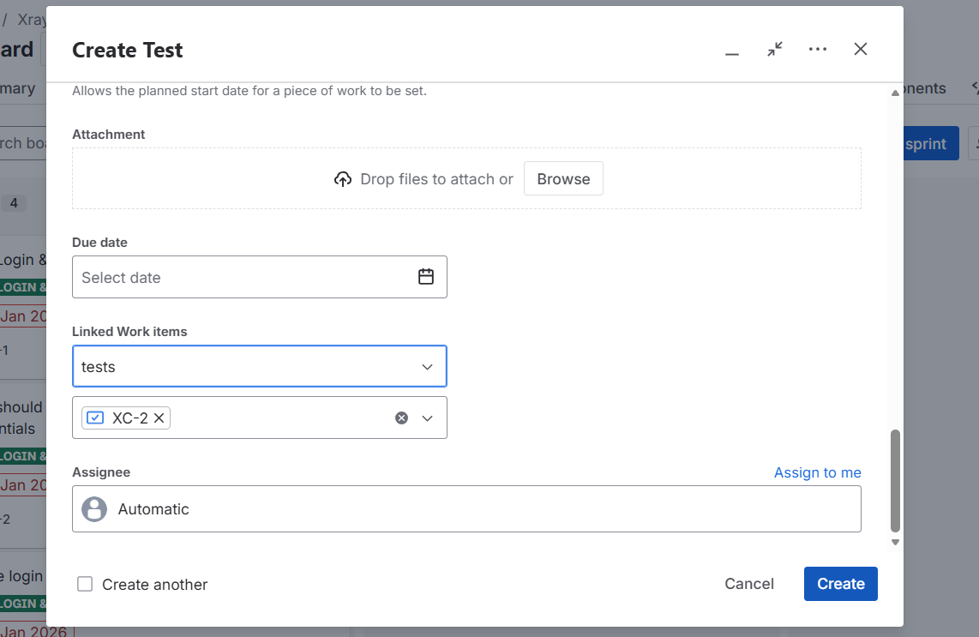

Once Test is created, view it so that you can see the options as shown below:

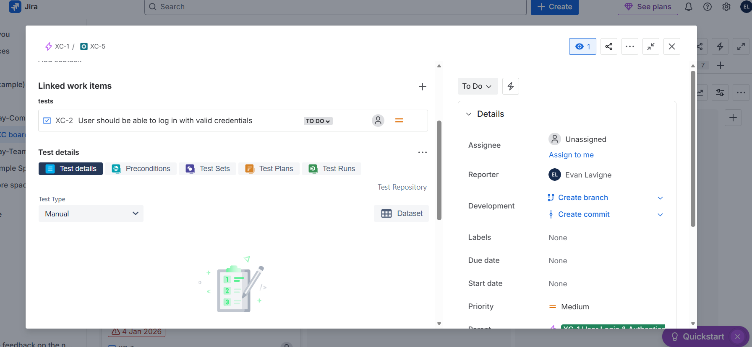

Choose Manual and write the steps for the test plan accordingly.

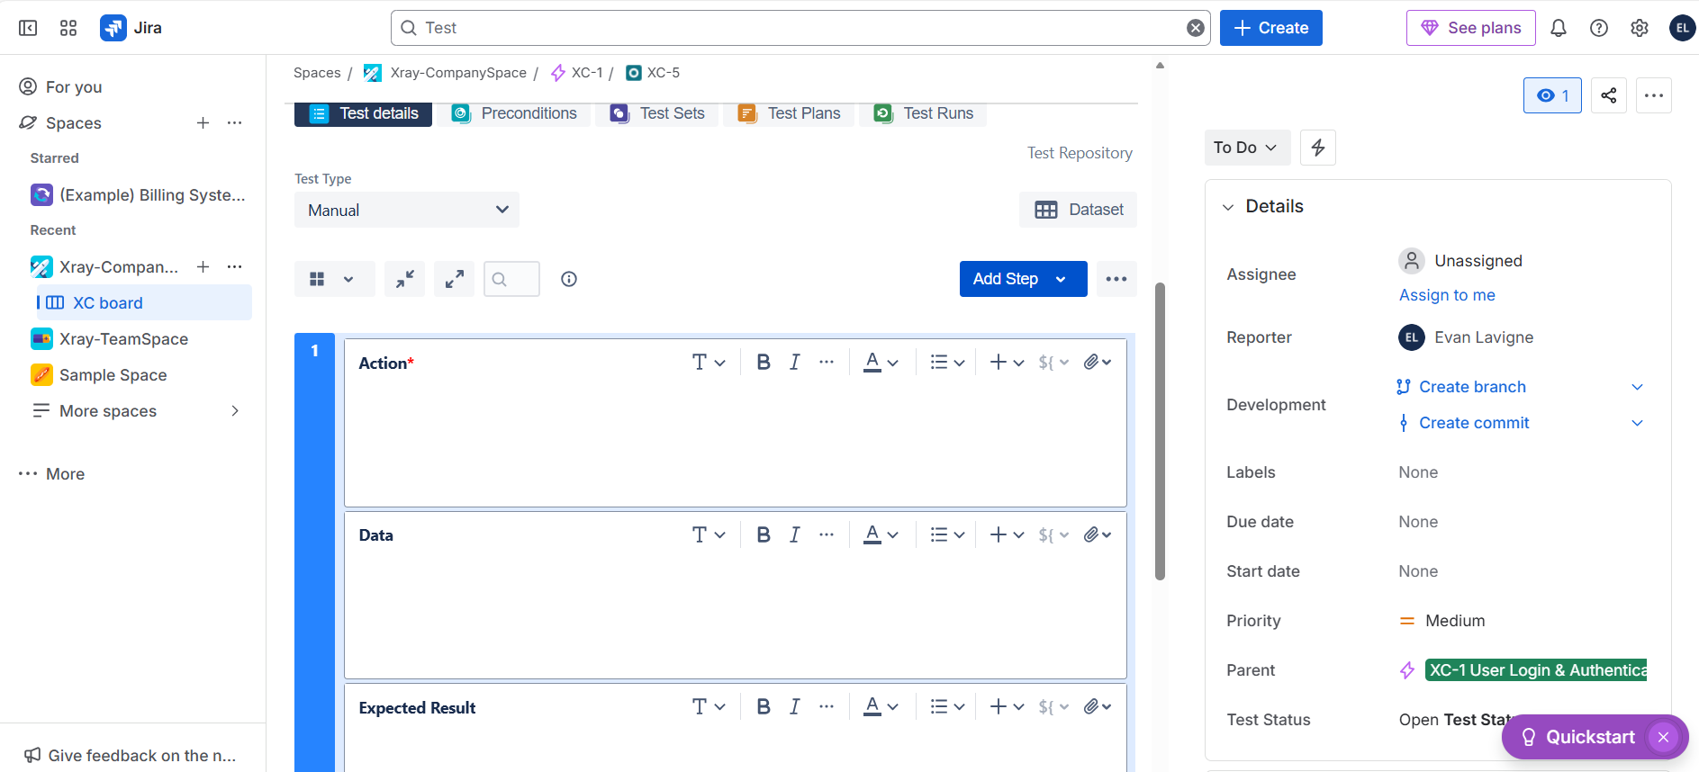

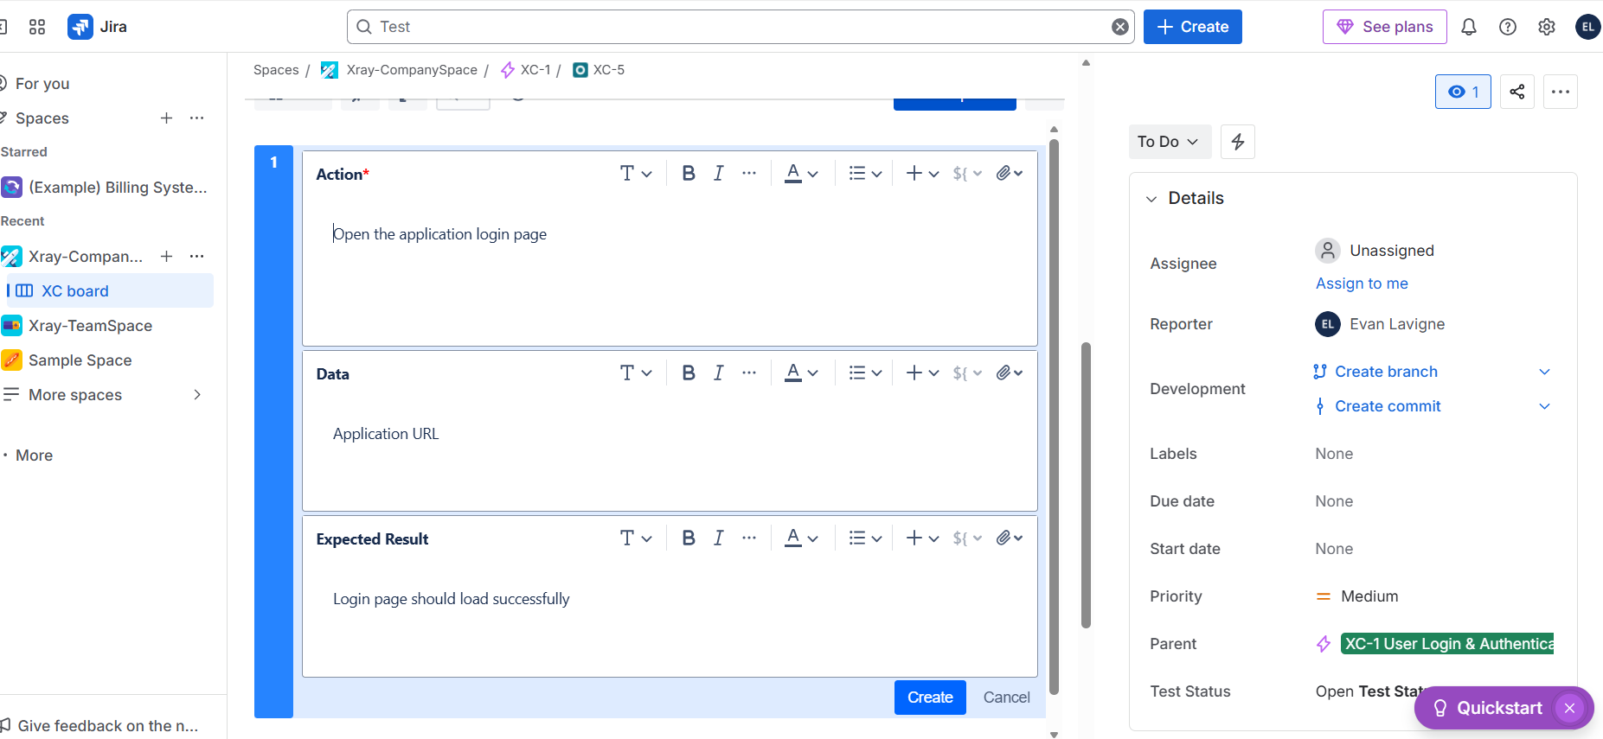

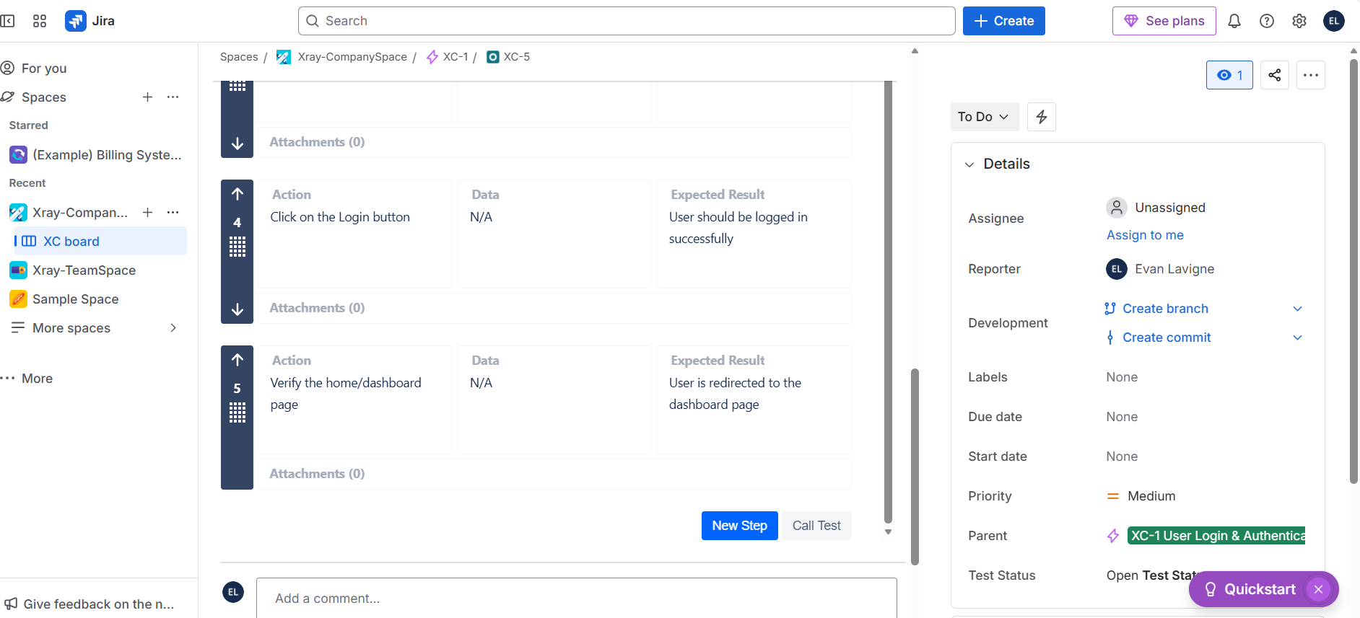

Create or choose existing Precondition.

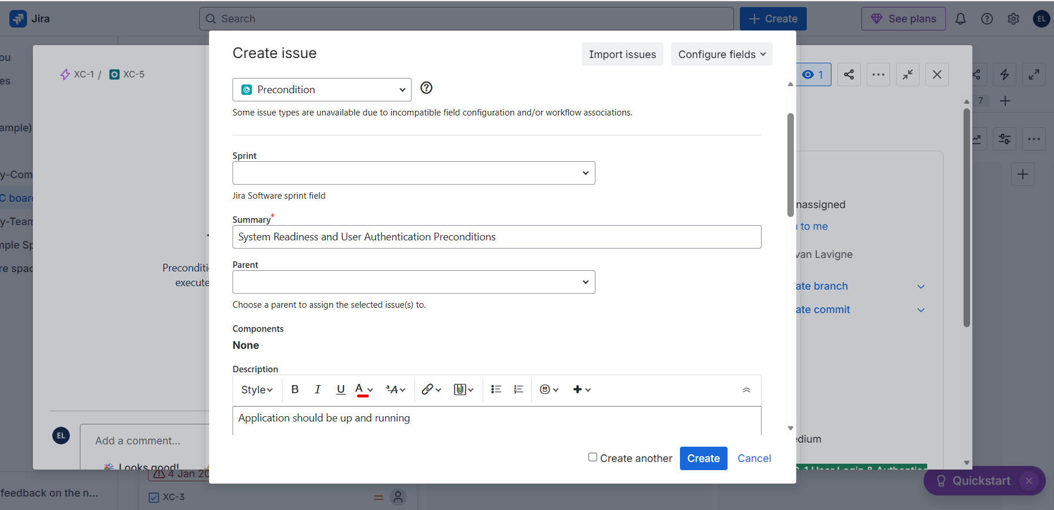

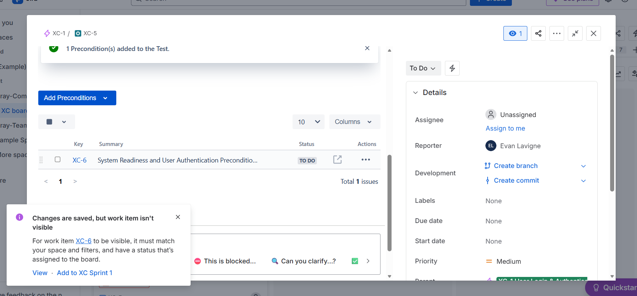

**Organise Test cases in Folders:**

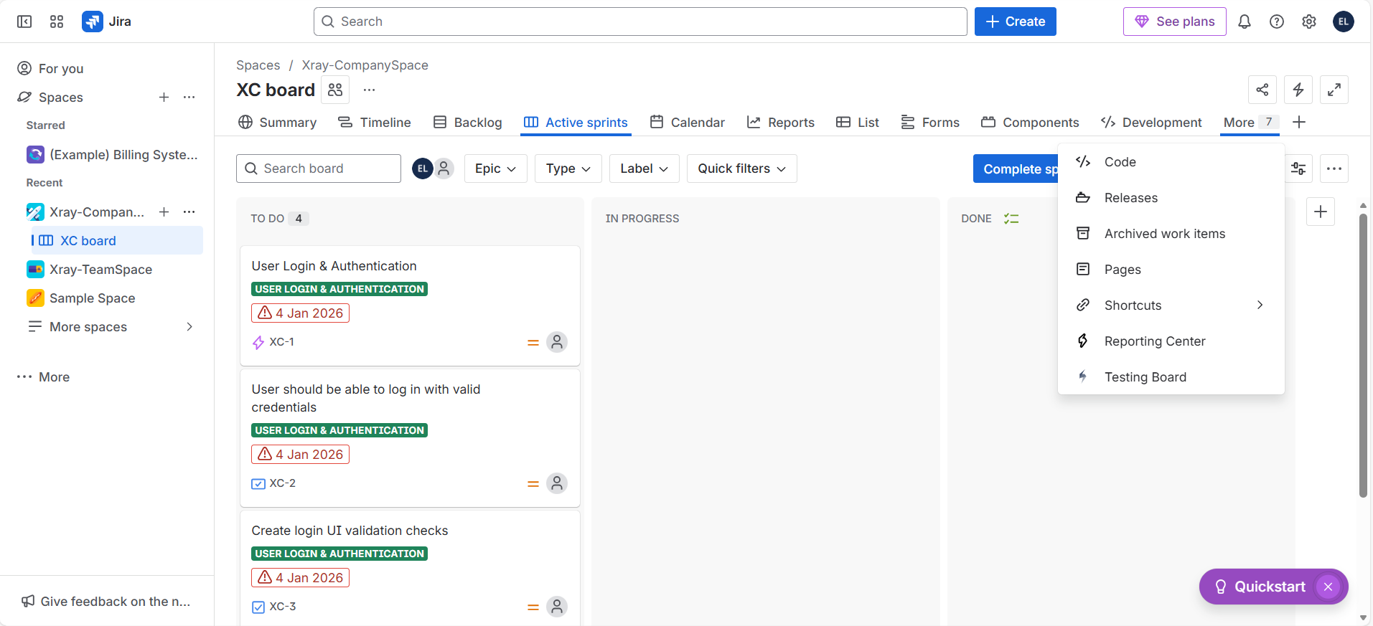

Click on Testing Board

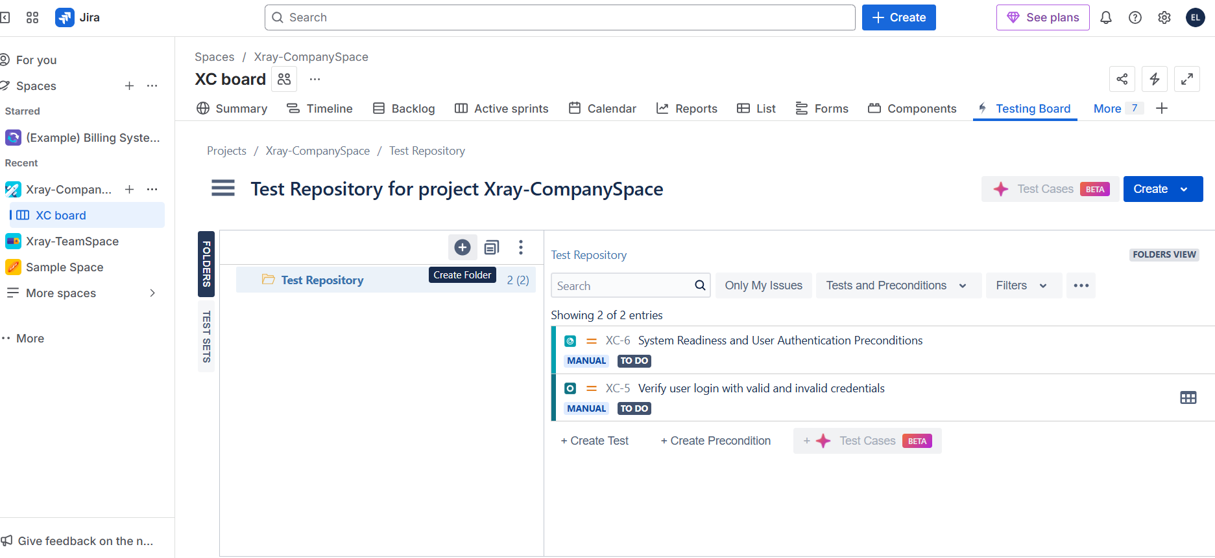

Create Folder and assign the name as per your need that it could be component name or Epic name etc.,

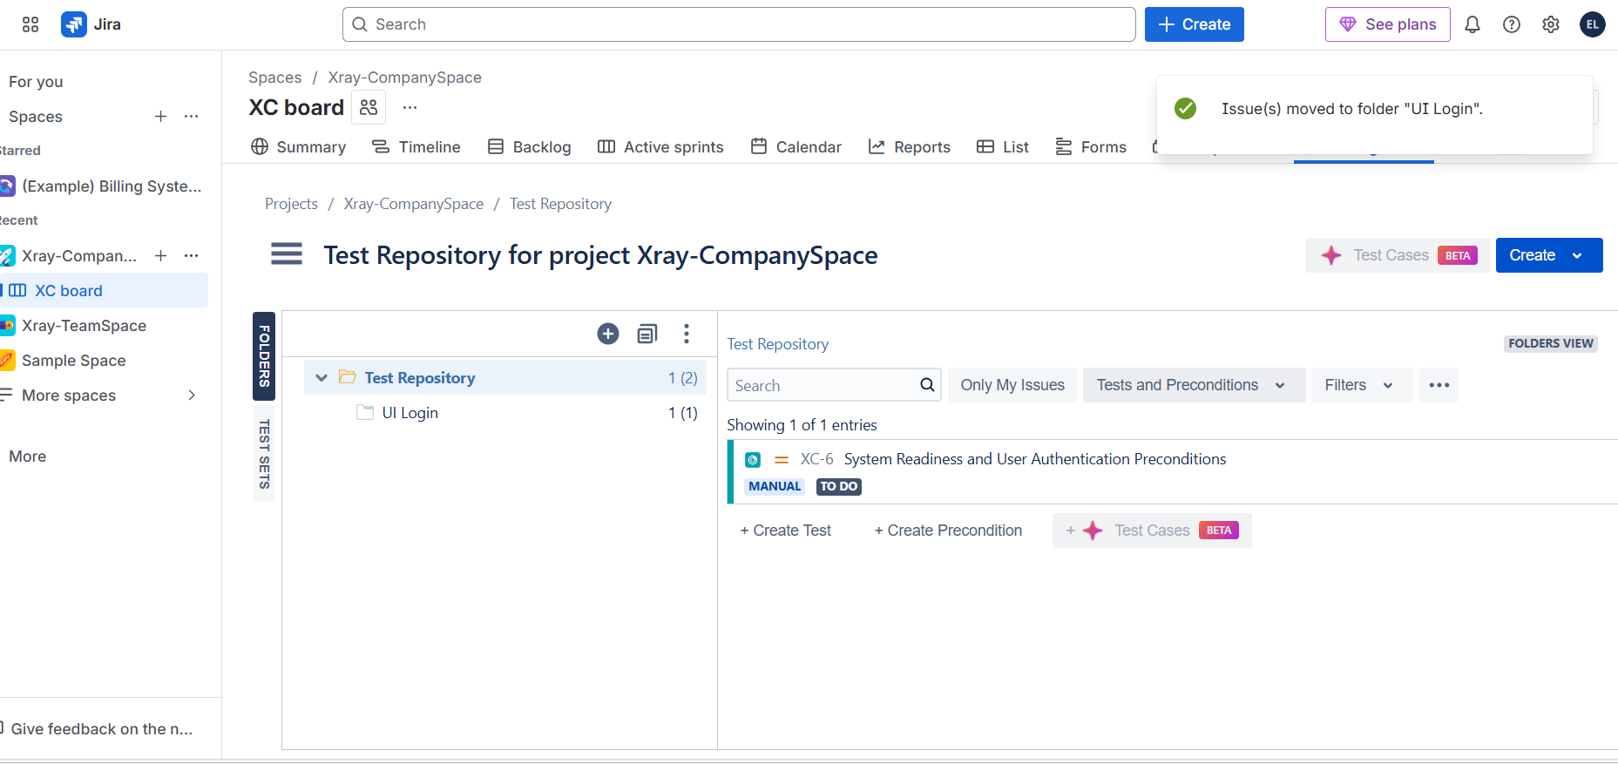

Drag and drop the Tests in their respective Folder as per the need then.

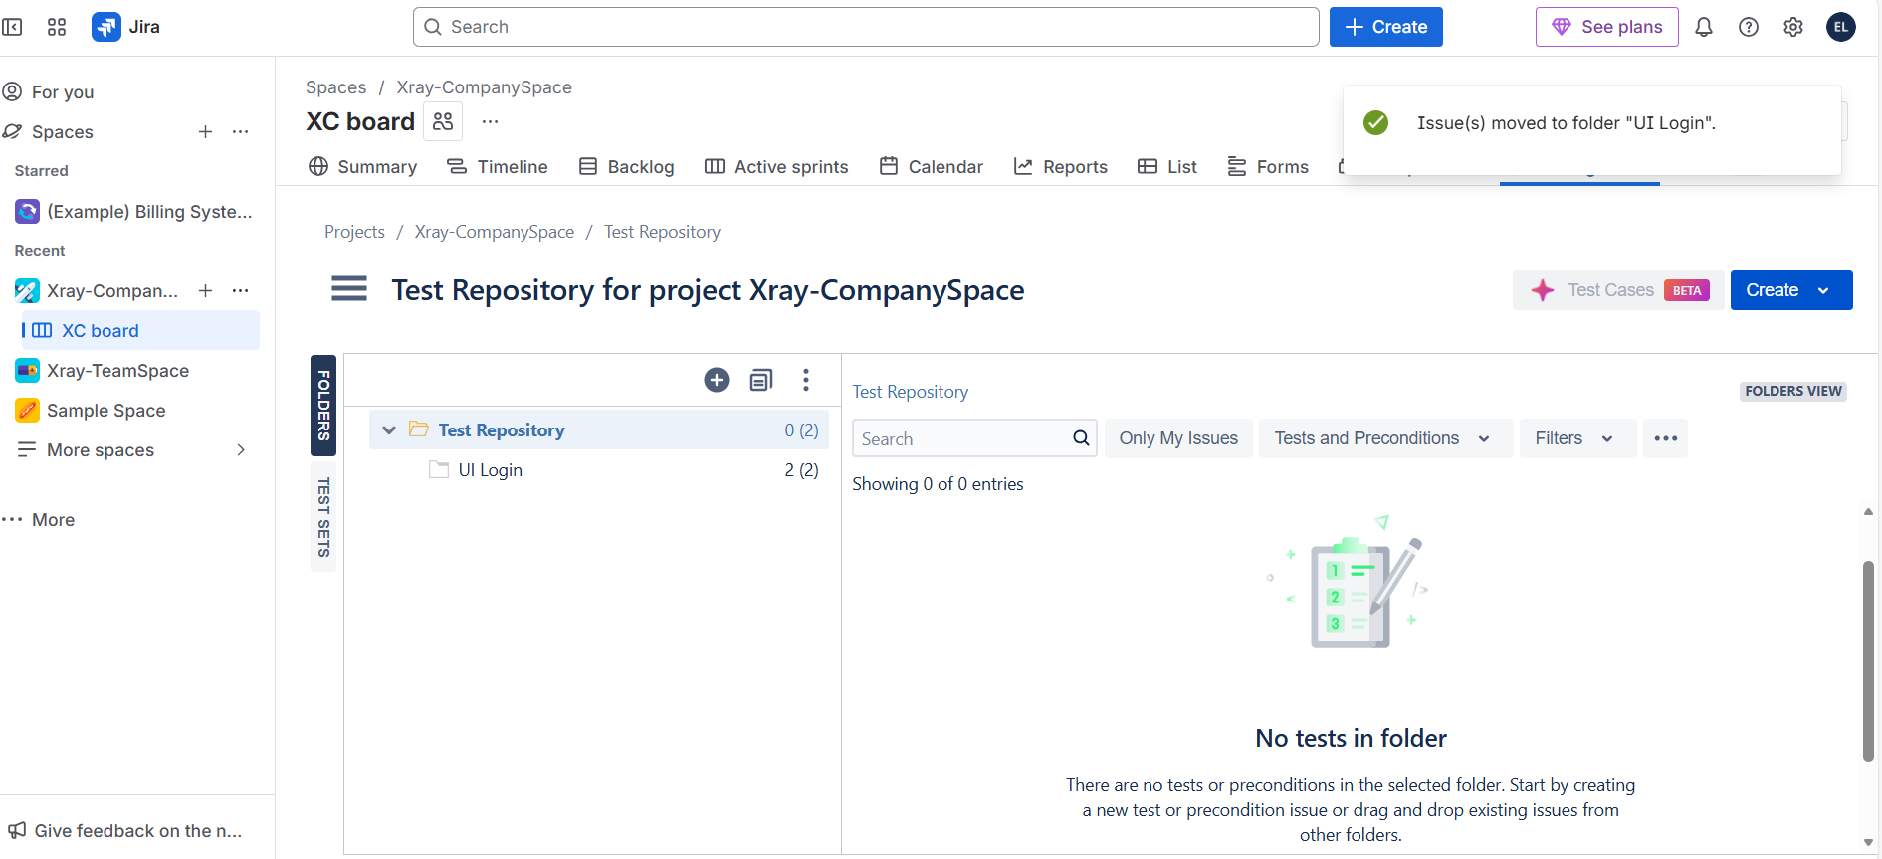

You can click on the folder and see the assigned tests over there. Also you can create tests, preconditions over there itself so that time gets saved 😊. Also you can name labels, component etc., from this test folder itself simply.

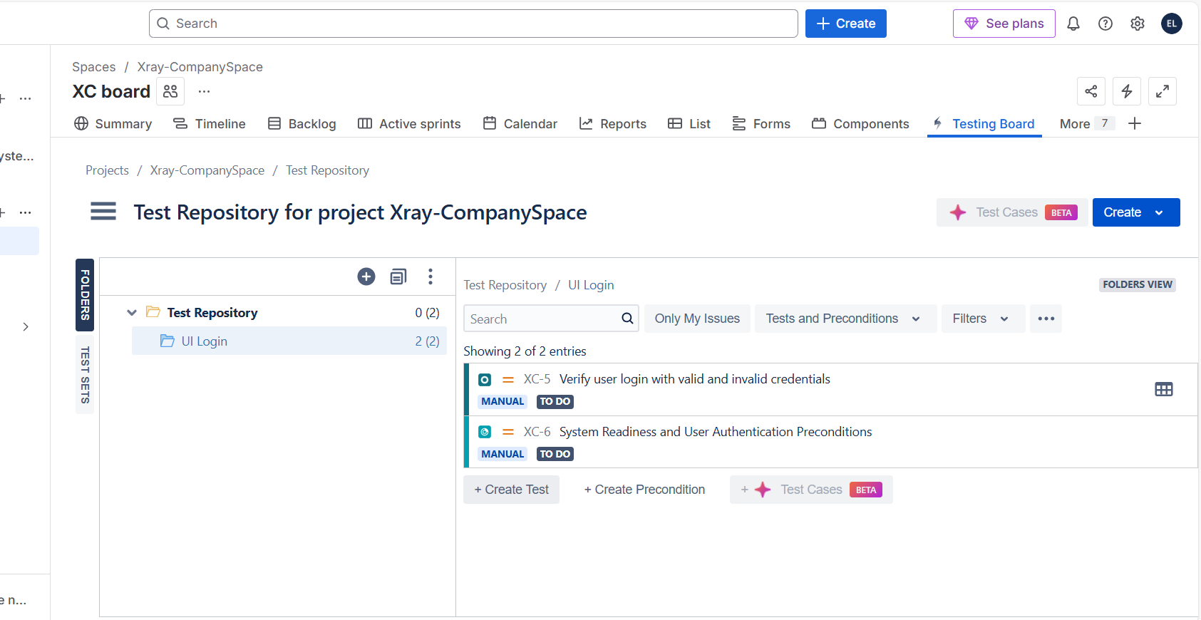

**Creating Parameterized Tests in Xray:**

--Same logic but different parameters Ex: Login page credentials.

To make this possible, click on Dataset to create Parameter.

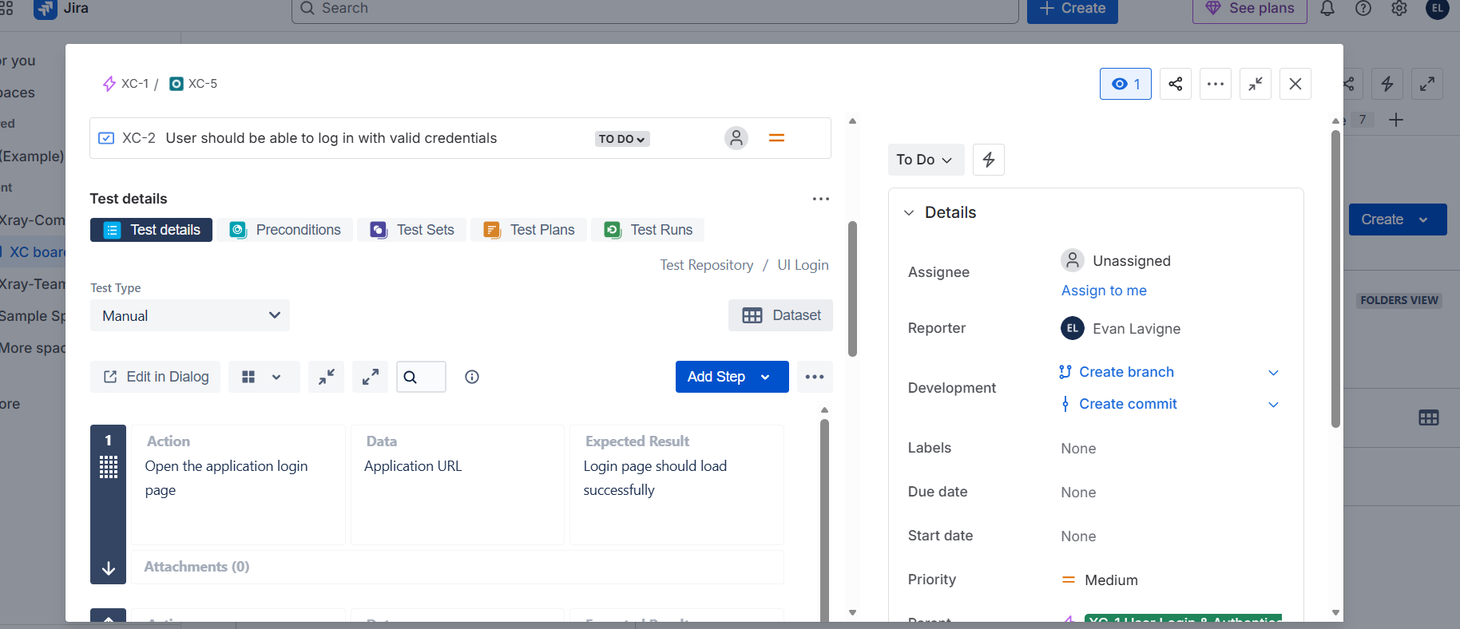

Click on create parameter or import the data from existing csv file:

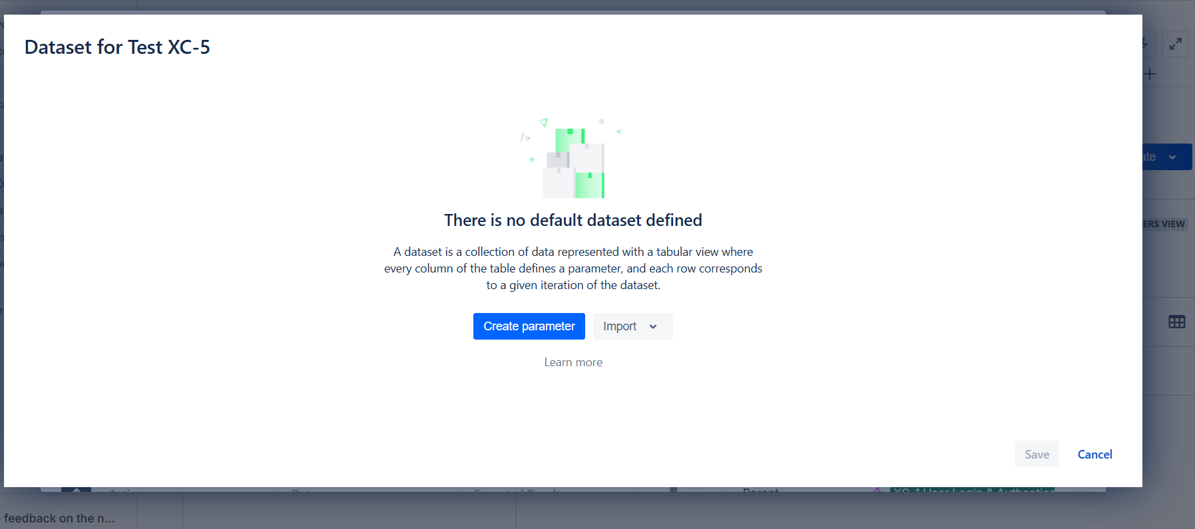

For login credentials as example, username, password and login successful become parameters and we just give some of them as data.

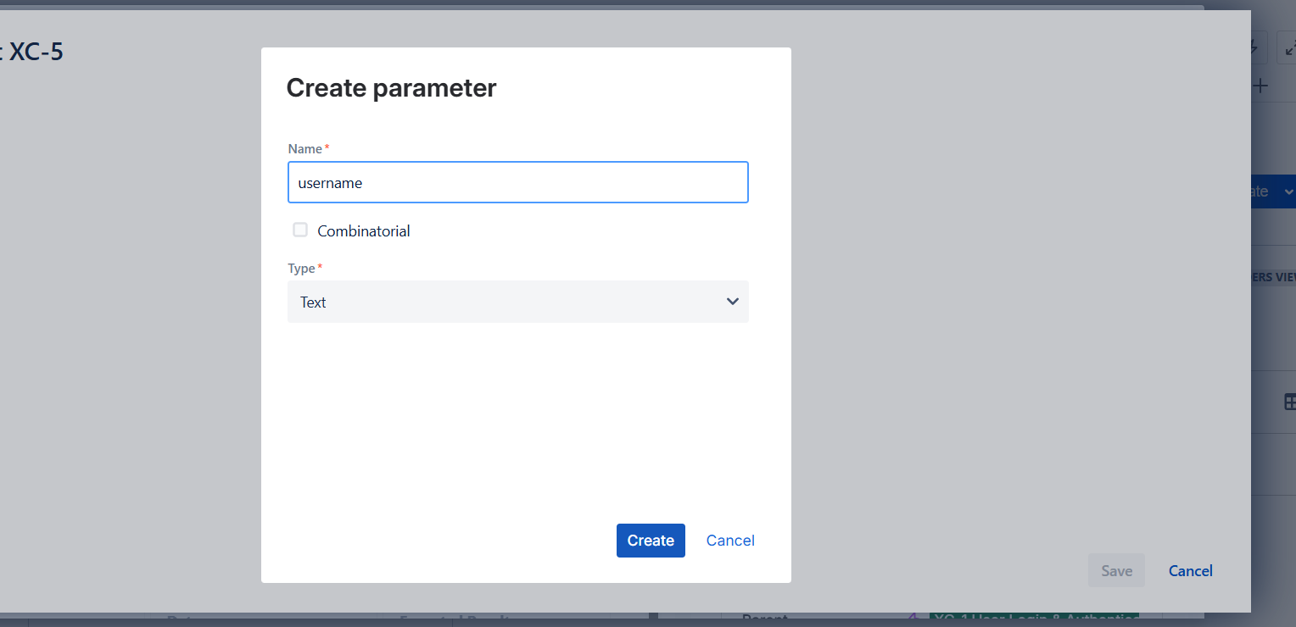

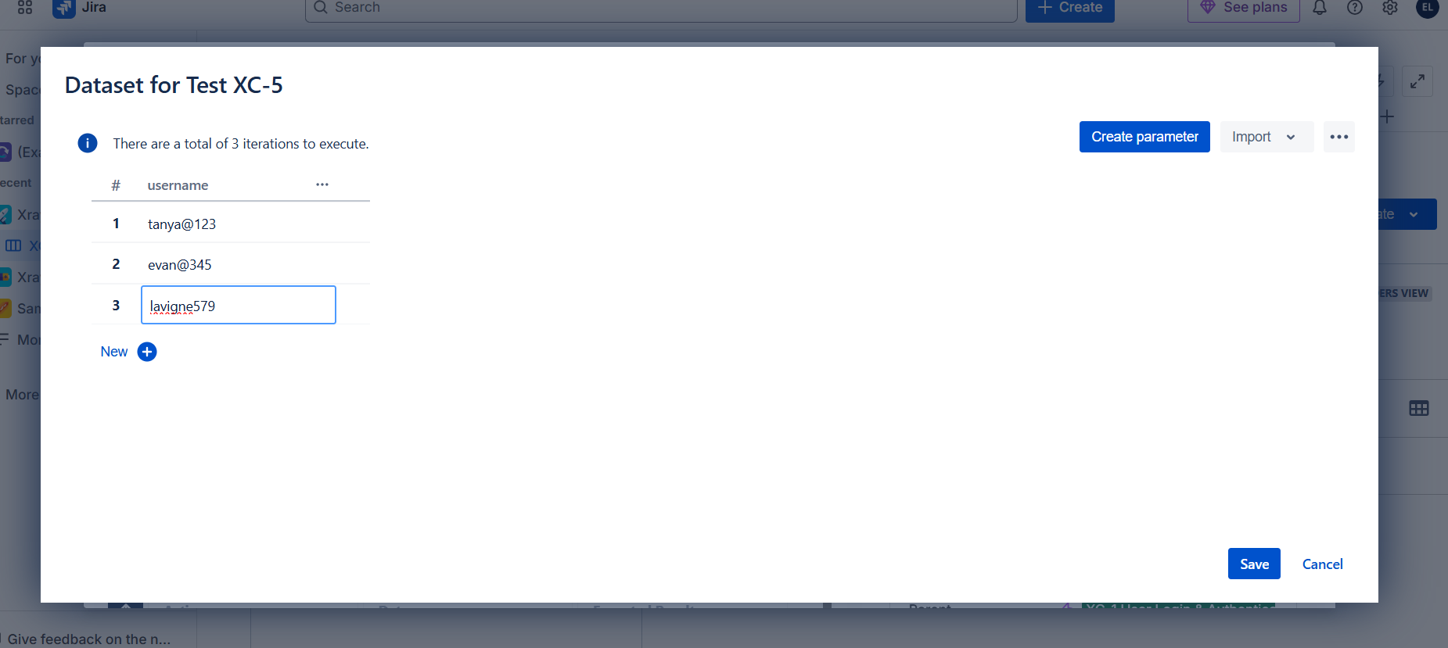

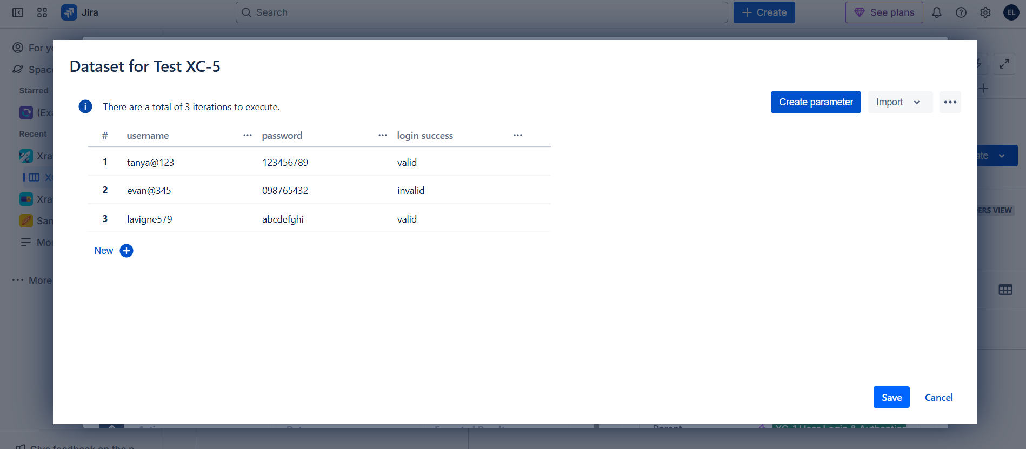

Now use the created paramters in the plan steps so that in future to run the test cases with the paramters assigned

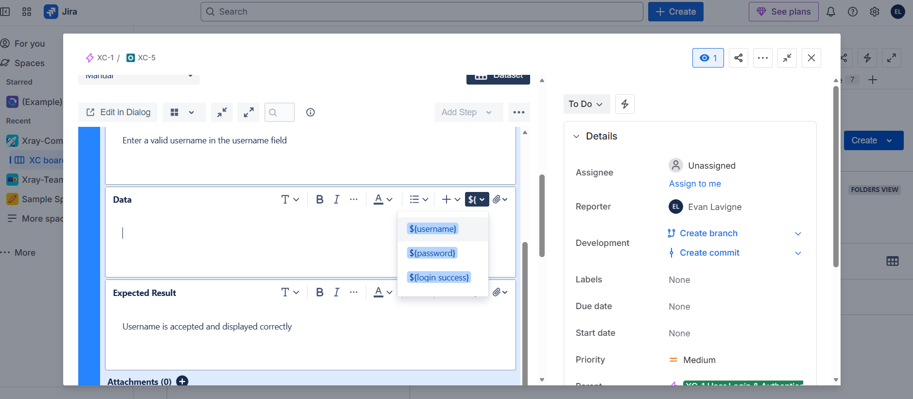

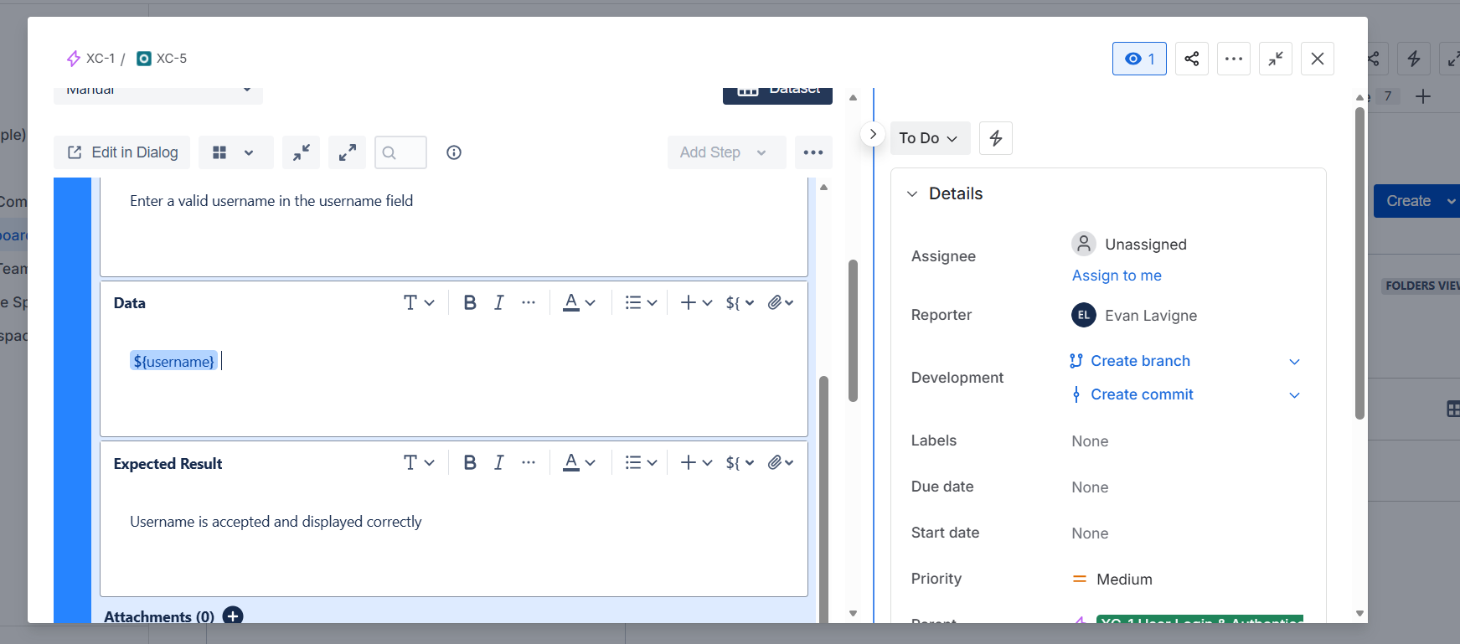

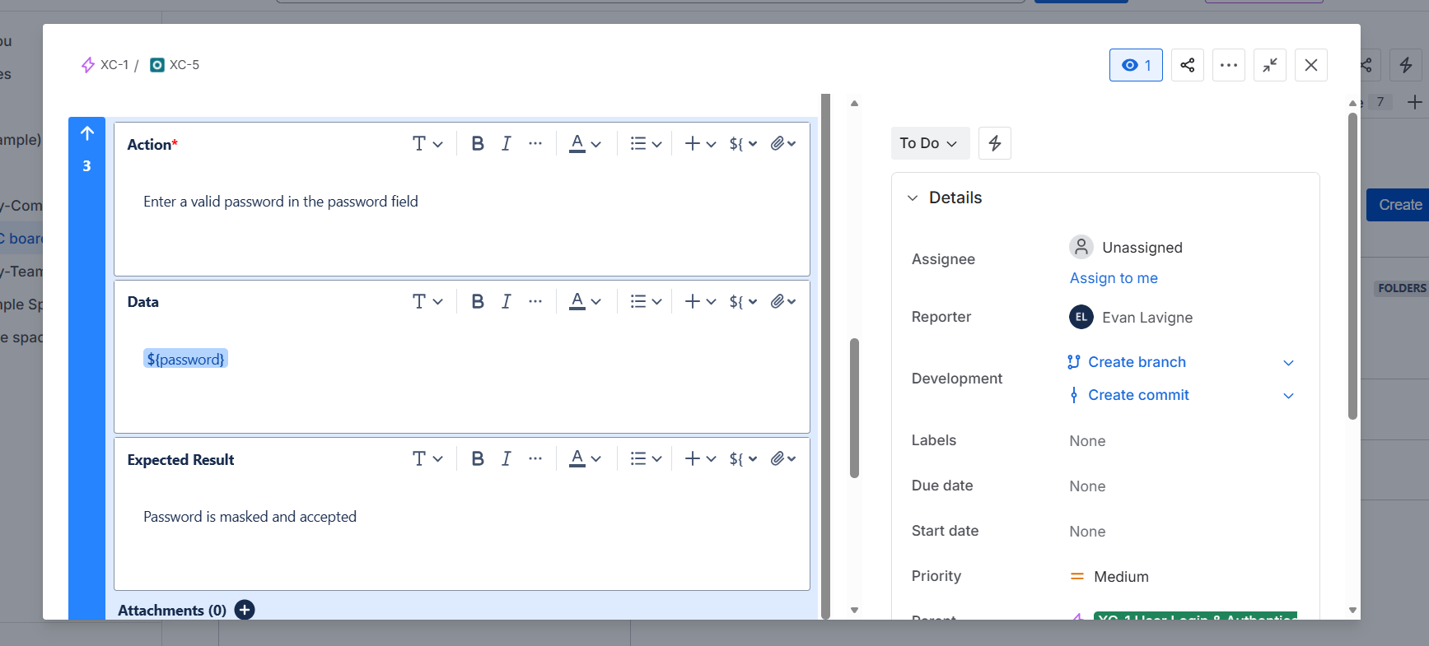

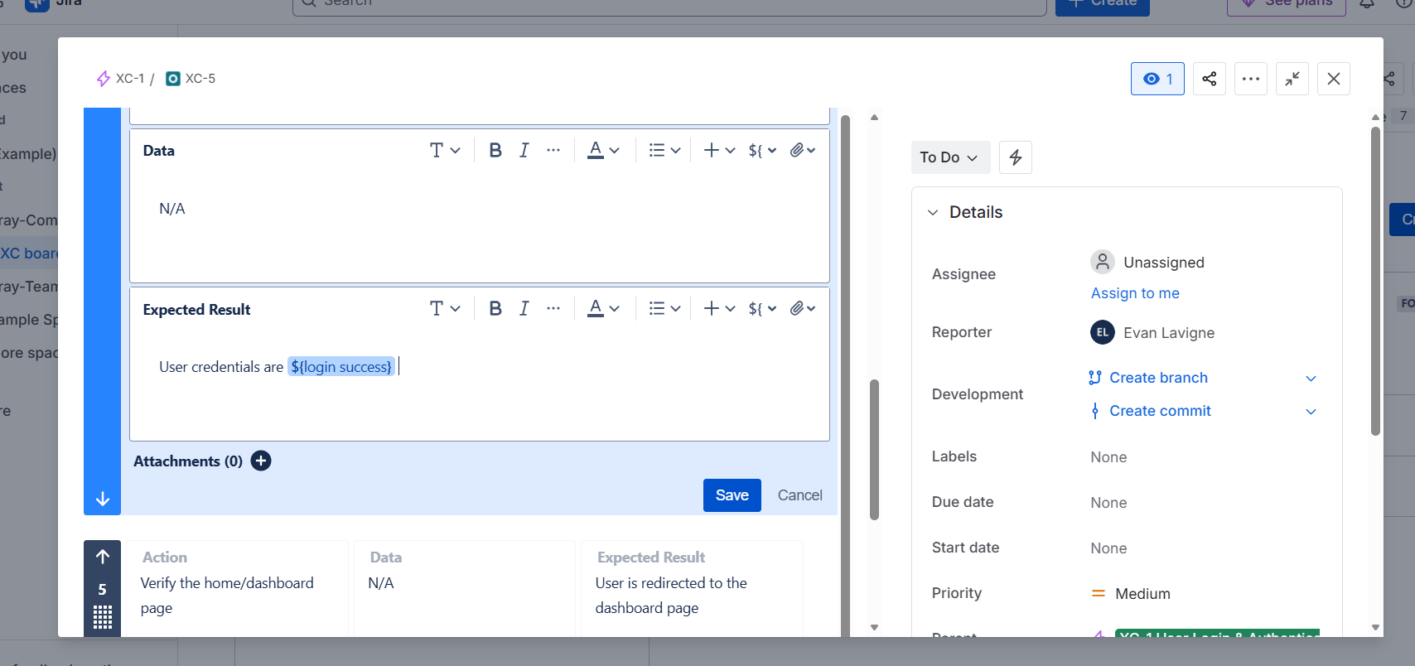

Click on Test Runs

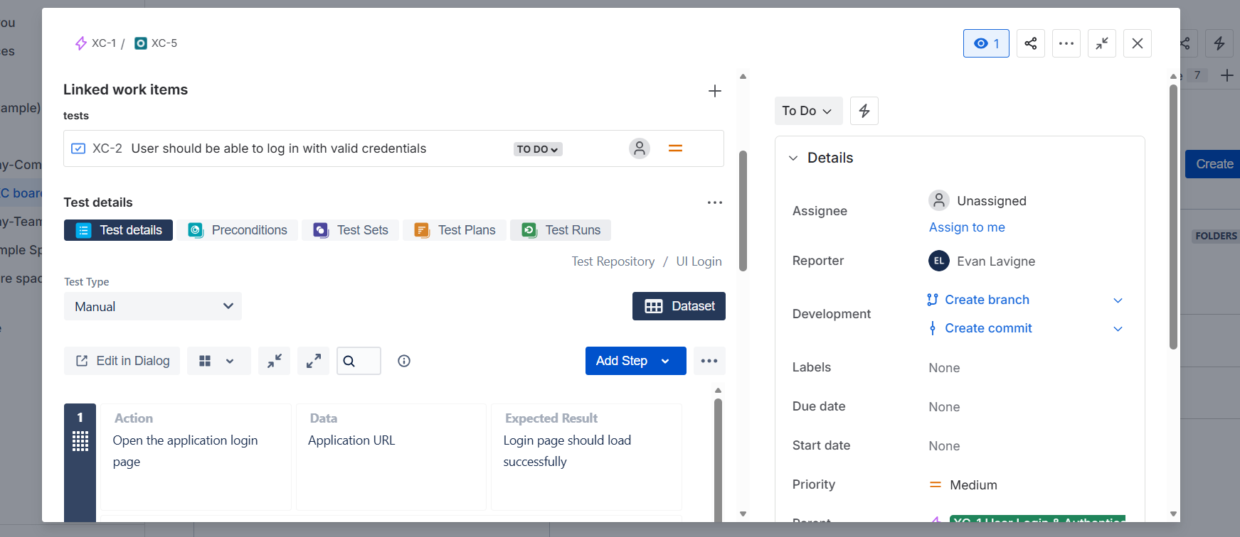

Click on New test execution

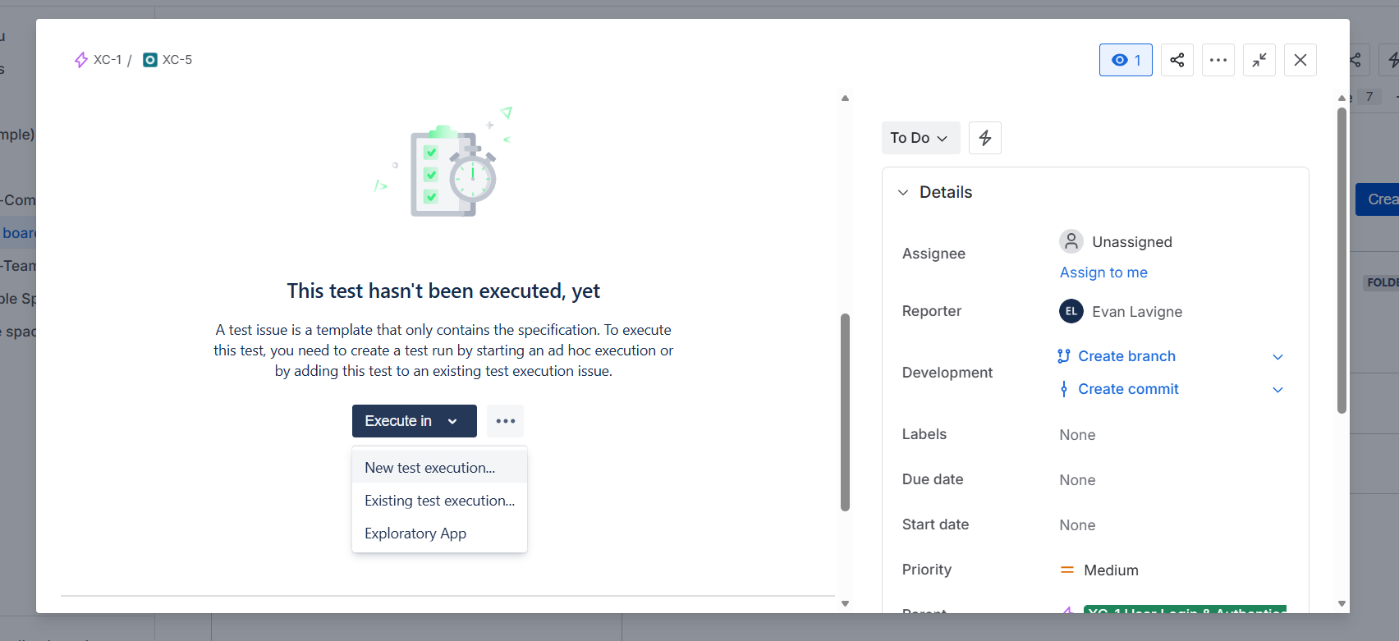

Just proceed create with the default values for now.

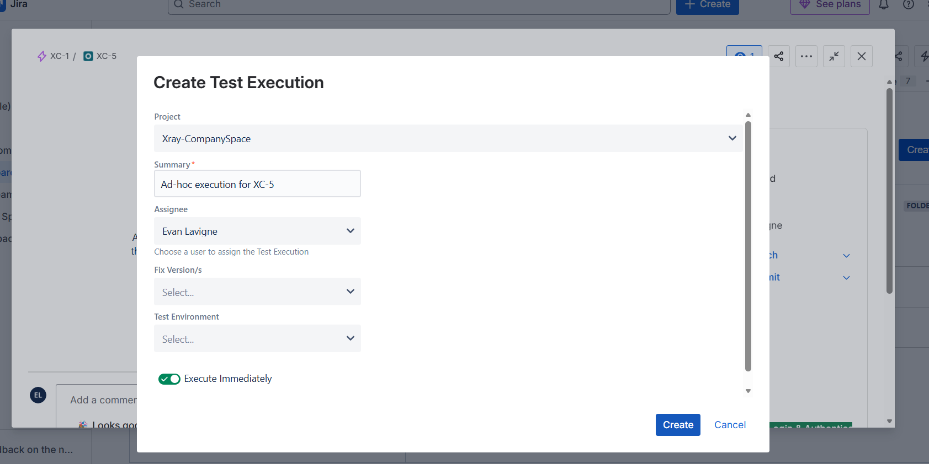

We can see the iterations in test details as shown below:

No need to create additional test cases for different parameters now leading to time save. 😊

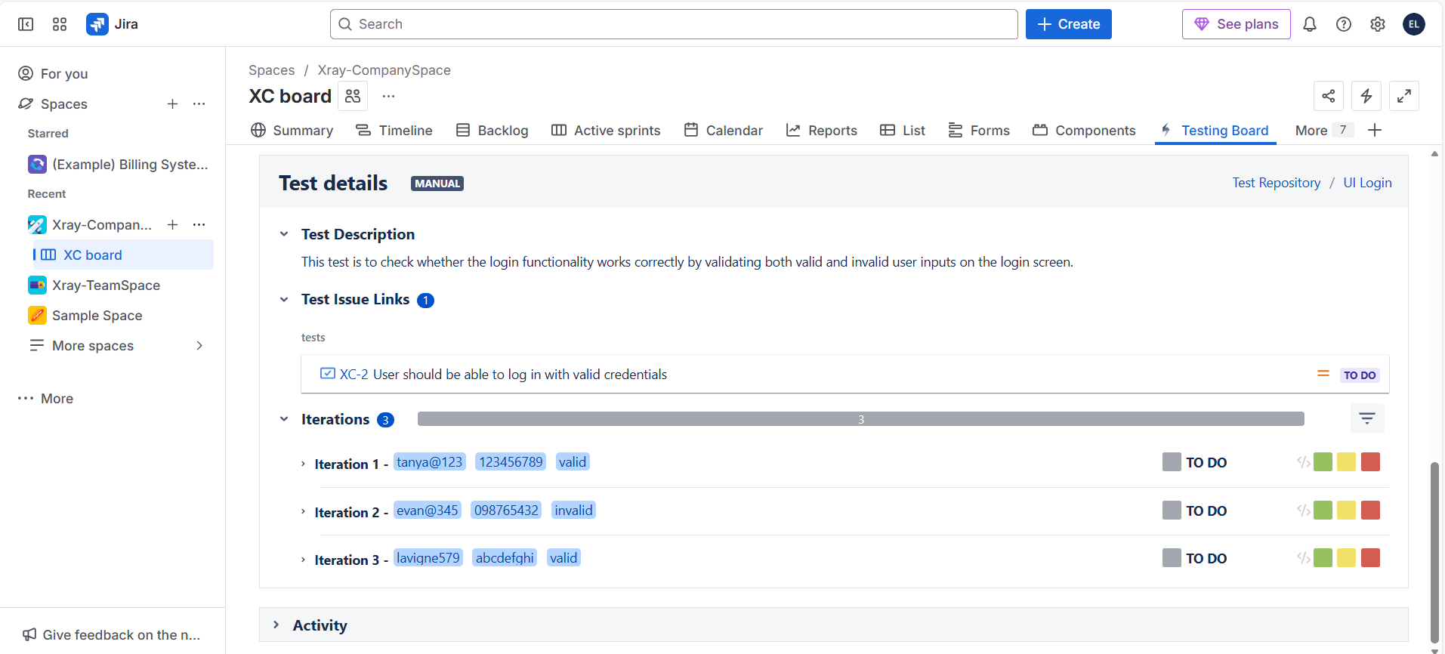

**Different Test Types in Jira Xray:**

Manual 🡪 step by step (already seen above)

Generic 🡪 for writing quick test cases 🡪 write everything elaborately in definition box

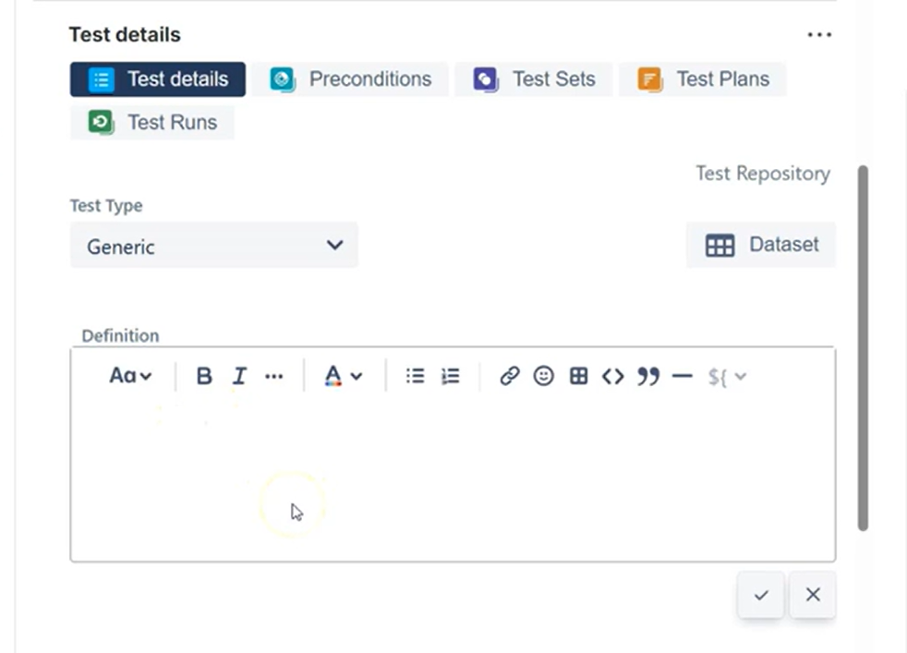

Cucumber 🡪 Scenarios are written using certain keywords ( press ctrl + space to pop up those words)

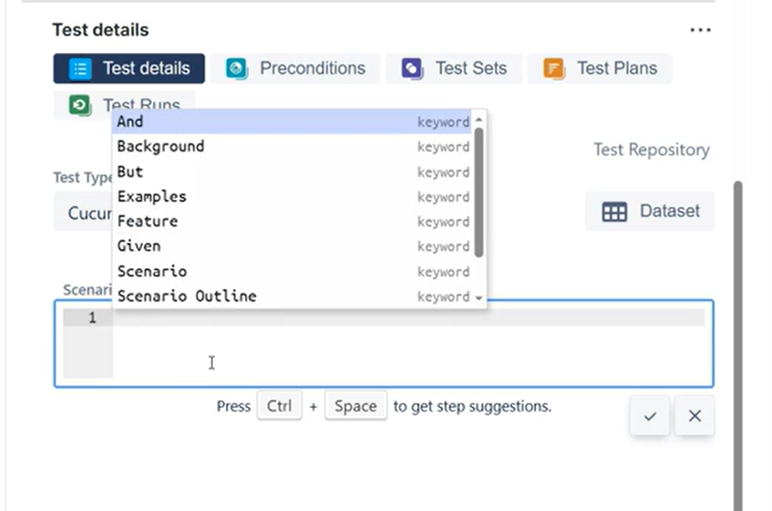

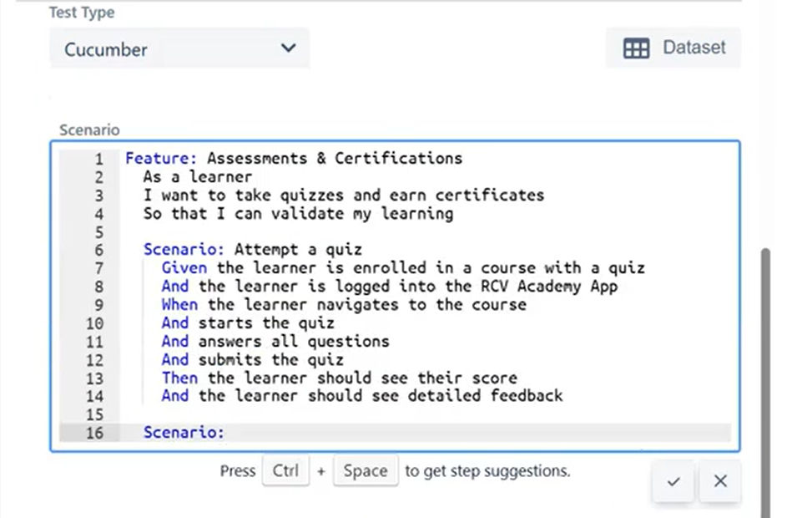

**List Parameters in Xray:**

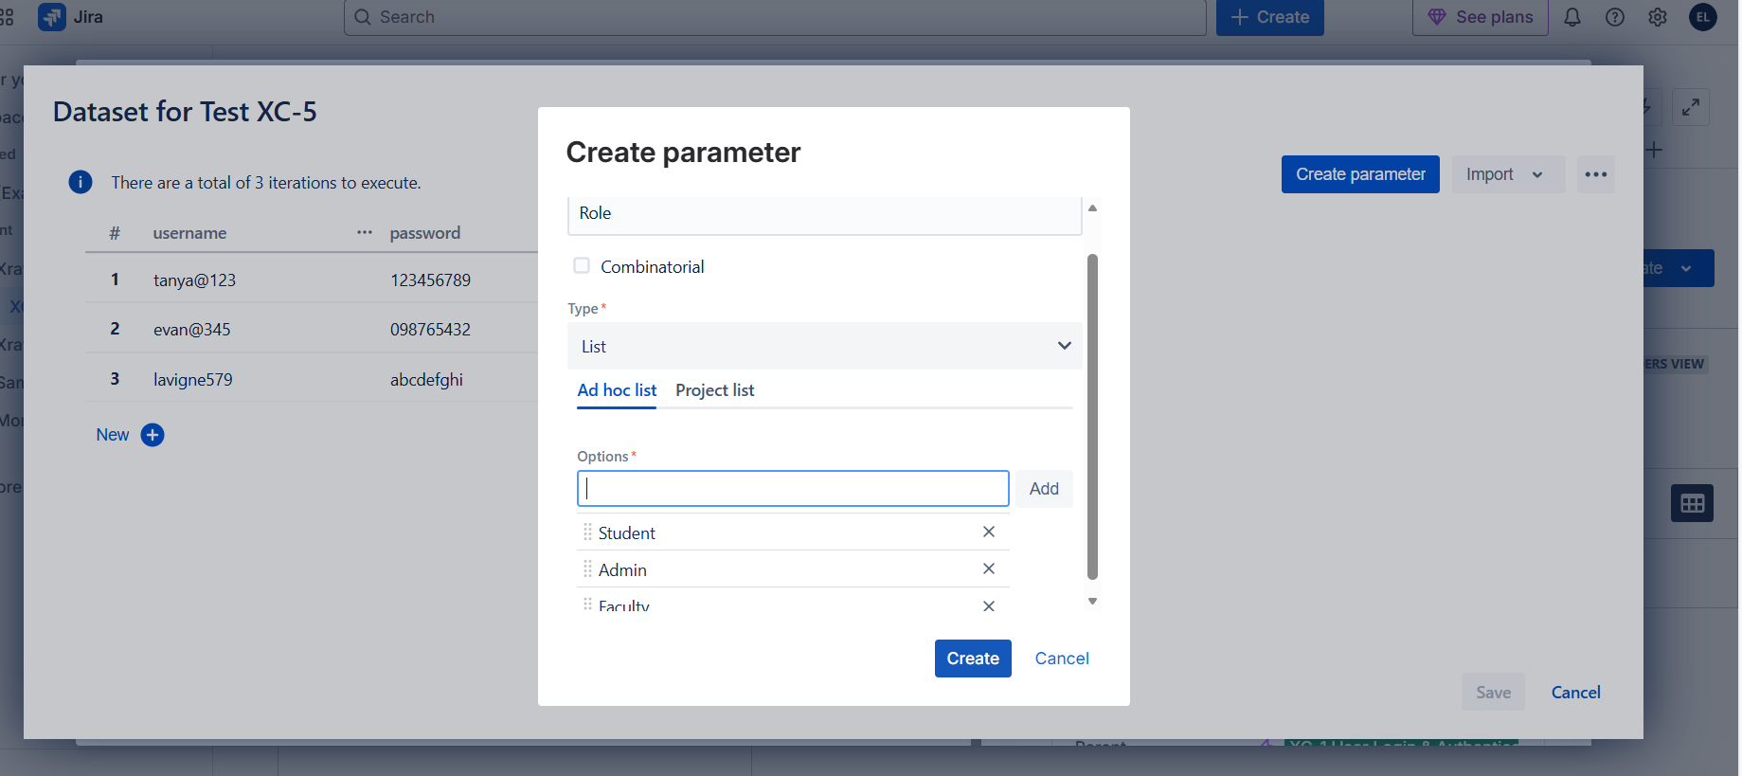

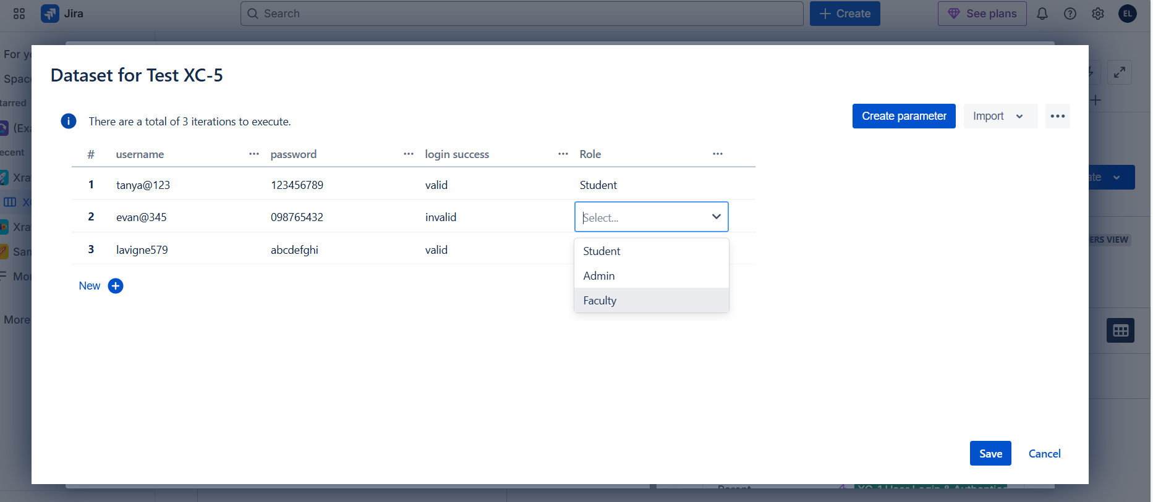

So far we created was just Ad hoc list. If we select on Project list 🡪 it’s a global level list which we create and reuse it in multiple projects where the same test case values can be used again & again and such that just choosing the already created Project list (global one) saves time 😊

